Module 2 – Model-Driven Apps UI/UX

**Goal**

To design a series of views & forms for the Vehicle table while adhering to UI/UX best practices.

**You will learn how to:**

* Create views & forms to display data
* Related fields and lookups
* Sub-grid controls, Timeline controls and Quick-View controls
* Charts and Dashboards

Table Of Contents

Start A New Model-Driven App 2

Create A New Vehicle Table View 15

Edit The Vehicle Main Form 23

Customize The Model Lookup Details 35

Filter Lookup Menu Items By Related Dropdown 39

Add A Sub-grid Of Recent Inspections 43

Insert A Timeline Control Into The Vehicle Form 49

Create A Custom Safety Certification Activity Type 56

Display Related Record Details In A Quick-View 67

Change The Icon For A Table 69

Create An Inspections Bar Chart 72

Add A Dashboard To The Model Driven App 75

Apply A Theme To A Model-Driven App (Optional) 85

## Start A New Model-Driven App

We will begin by creating a Model-Driven App. The app will enable employees to conduct inspections and manage master data such as: vehicles, customers and inspection templates

1. Open the Vehicle Inspections solution and create a new model-driven app.

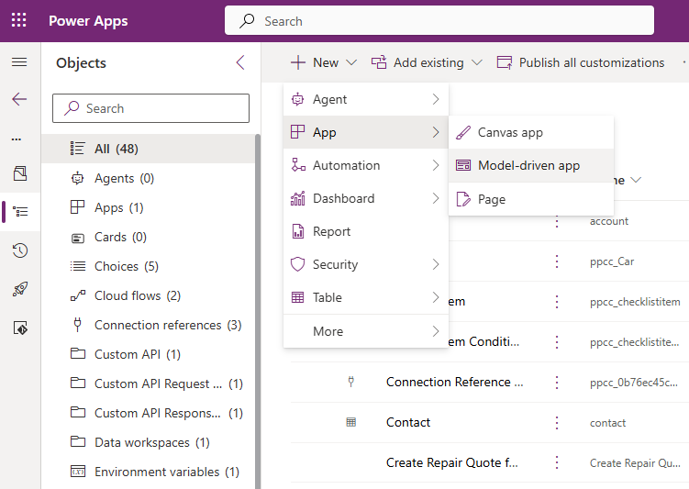

1. Name the app “Vehicle Inspection Management”. Press the Create button.

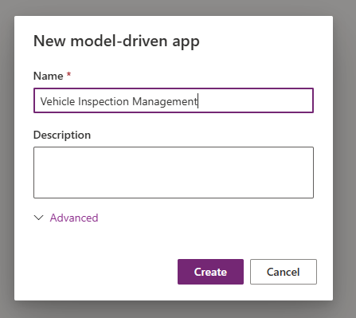

1. Add a new Dataverse table to the Vehicle Inspection Management app.

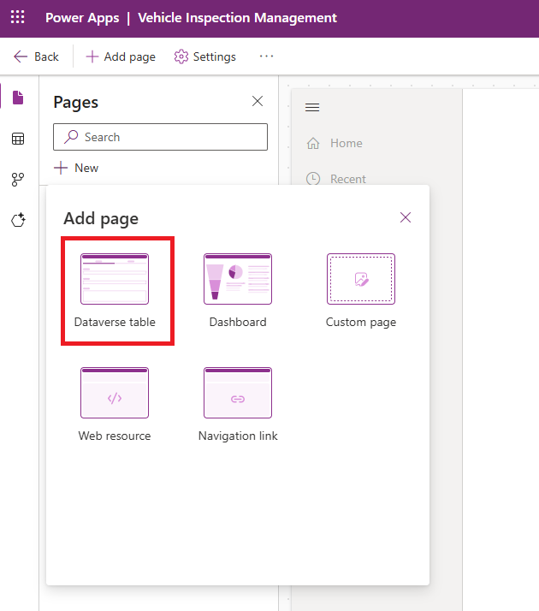

1. Select the following tables:
   * Contact
   * Inspection
   * Repair Quotes
   * Vehicle

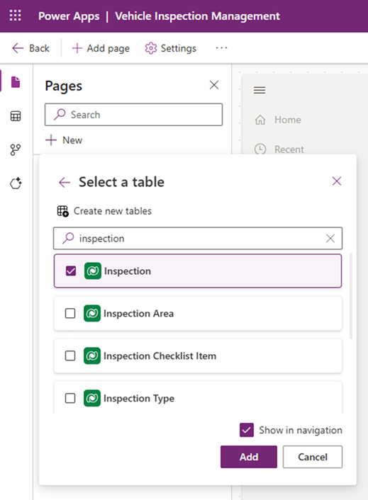

1. After the tables are added the app should look like this.

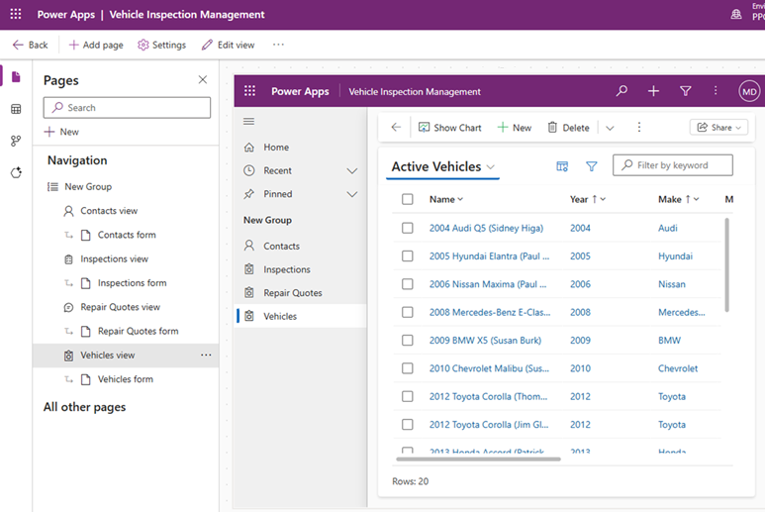

1. Select the “New Group” in the navigation menu and rename the title “Inspections”

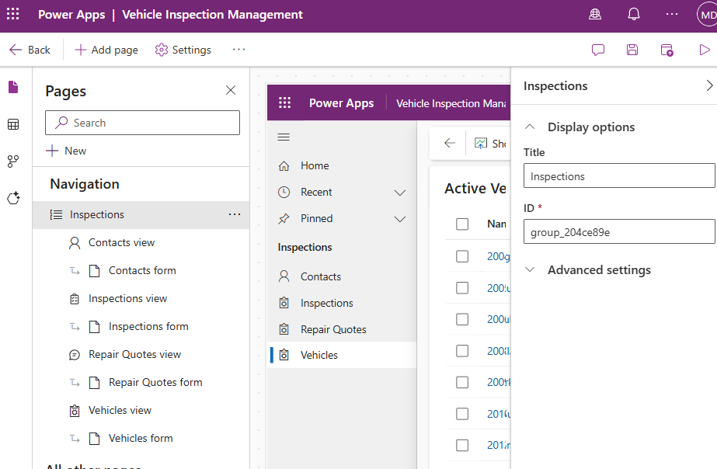

1. Open the Settings menu.

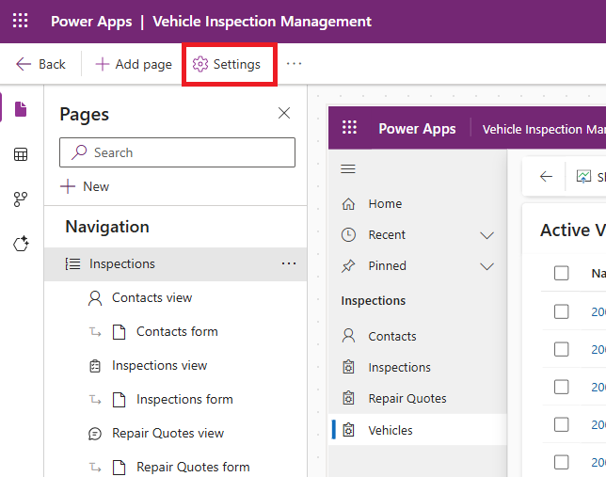

1. Go to the Navigation sub-menu. Check the Enable Areas setting. Close the Settings menu.

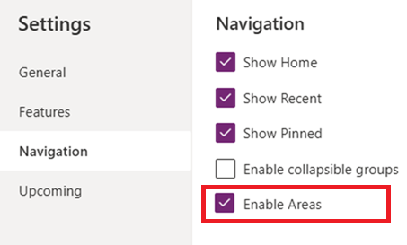

1. Select the Areas menu. Click on the three-dots and Edit properties. Change the Area name to Inspections Management.

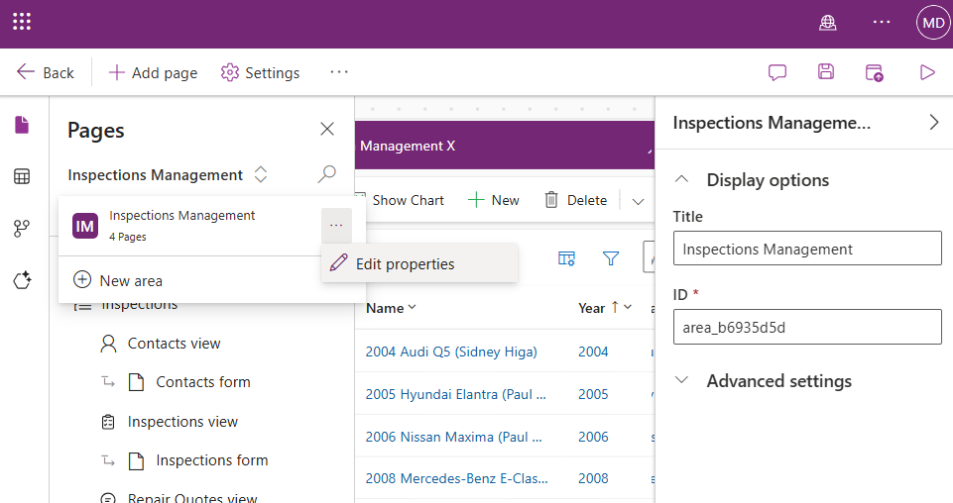

1. Create a new area

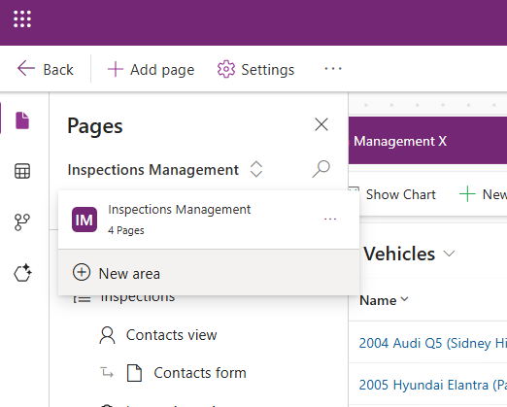

1. Name the Area “Master Data”

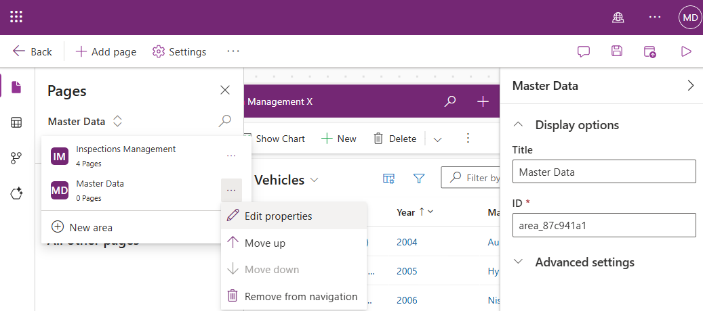

1. Rename the “New Group” to “Vehicle Info” and add the following tables:
   * Vehicle Manufacturer
   * Vehicle Model
   * Vehicle Model Year
   * Vehicle Trim

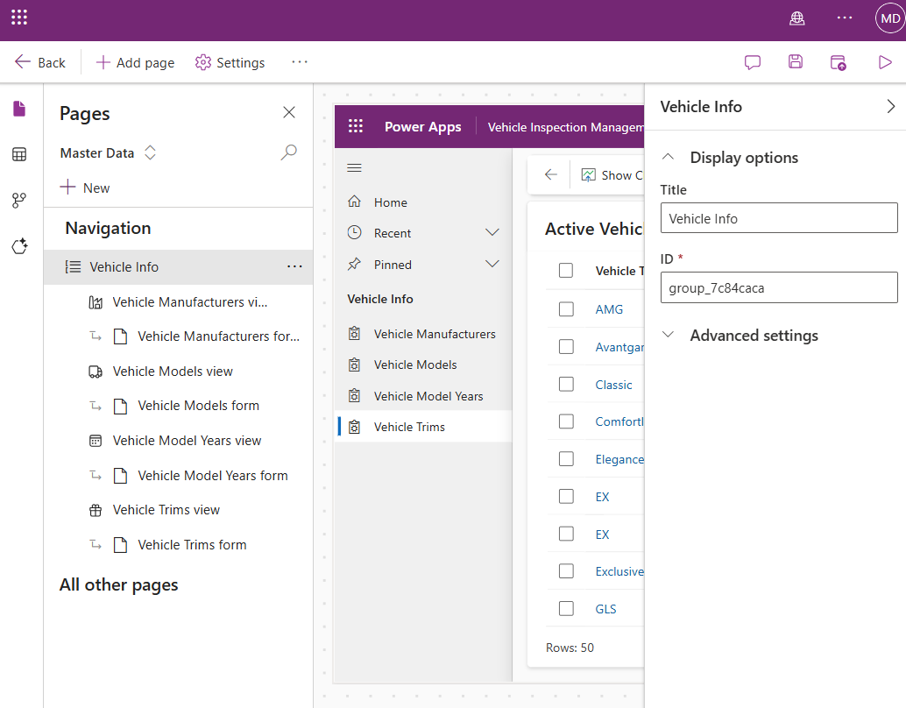

1. Add another New Group to the Master Data area.

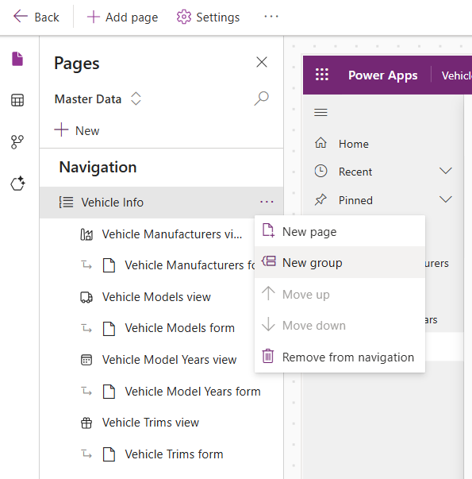

1. Add the following tables to the Master Data area:
   * Checklist Item
   * Inspection Area
   * Inspection Type
   * Inspection Type Area

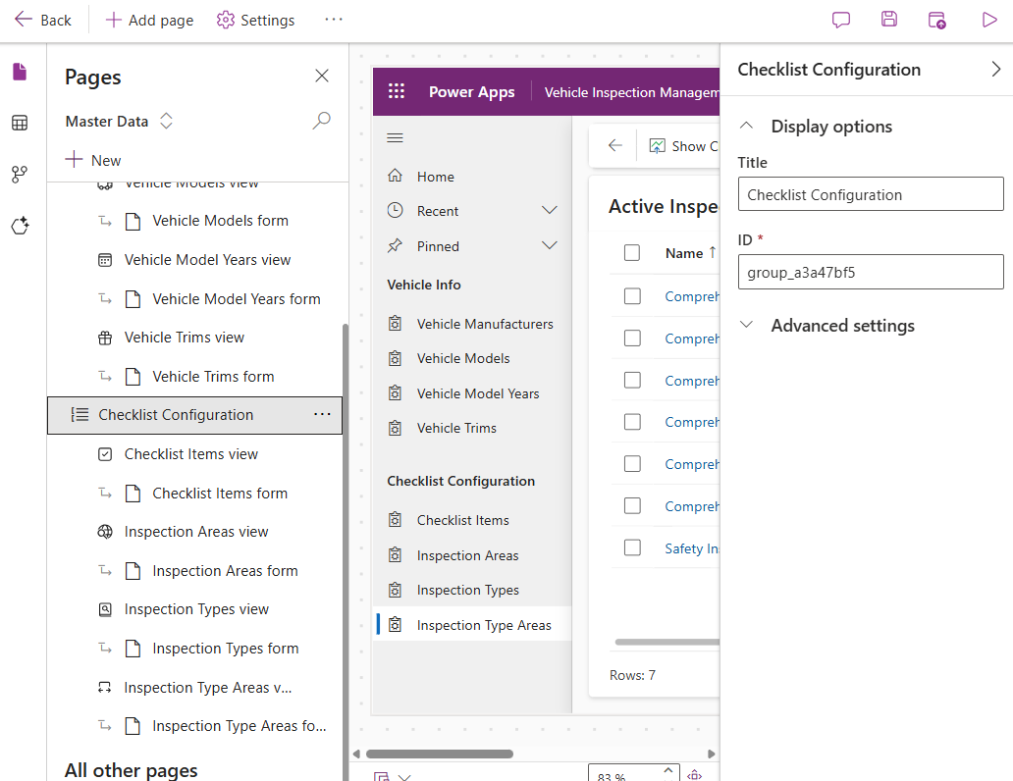

1. Save and Publish the model-driven app.

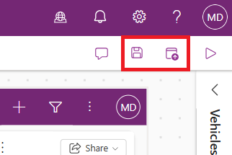

## Create A New Vehicle Table View

We will begin by creating a new Dataverse view for the Vehicles table. The purpose of this view is to show a list of vehicles that need an annual safety inspection soon to a salesperson. It also includes the owner of the vehicle and a phone number to call them at.

1. Open the Safety Inspections solution and go to the Vehicle table.
2. Goto the Views menu for the Vehicle table then select New view.

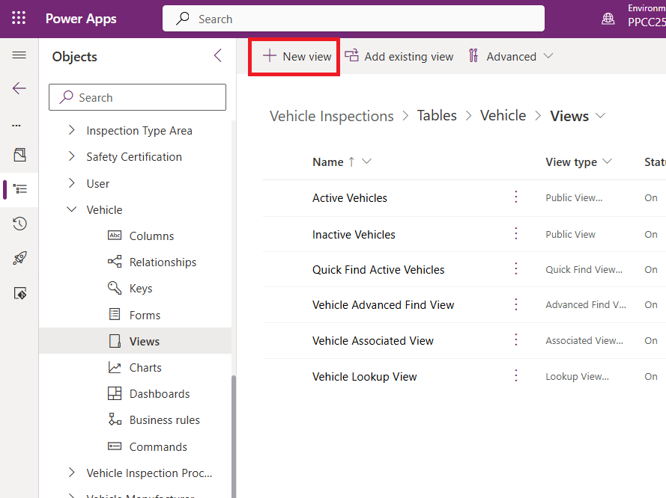

1. Name the view *Annual Vehicle Safety Reminders*. Uncheck Get AI-generated column suggestions then press Create.

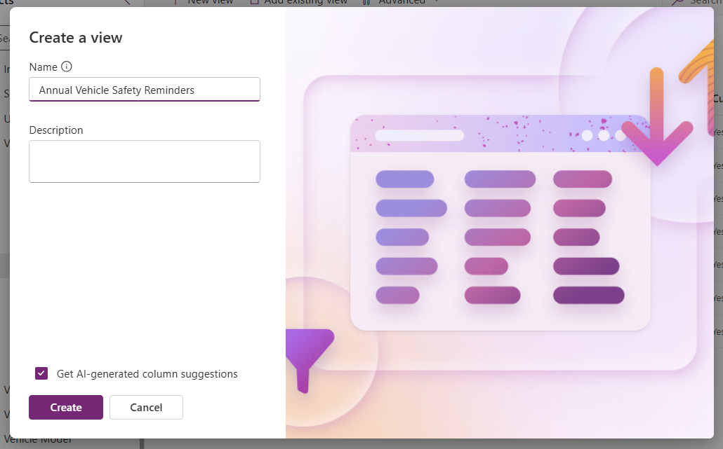

1. When the Views Editor appears the new View will include only a single Name column.

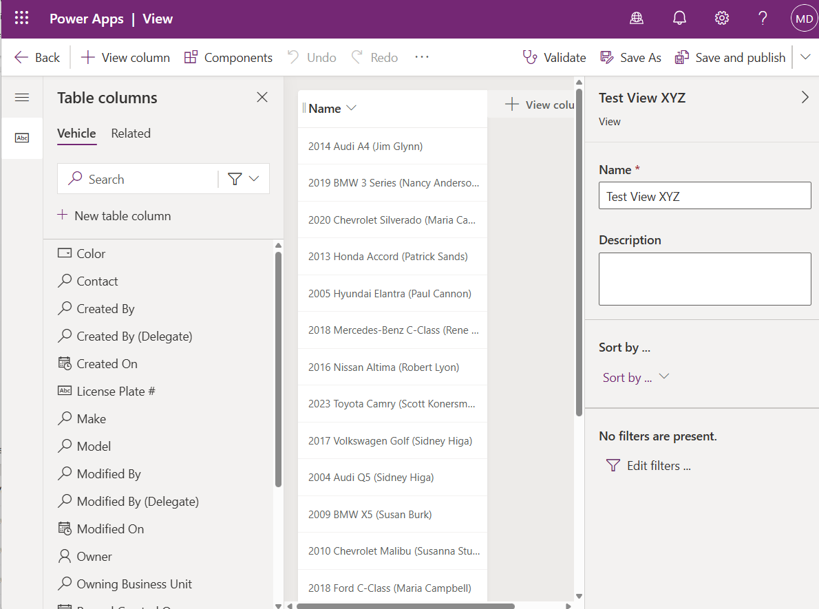

1. Select the Vehicle tab and add the columns Year, Make and Model to the view by clicking on their names.

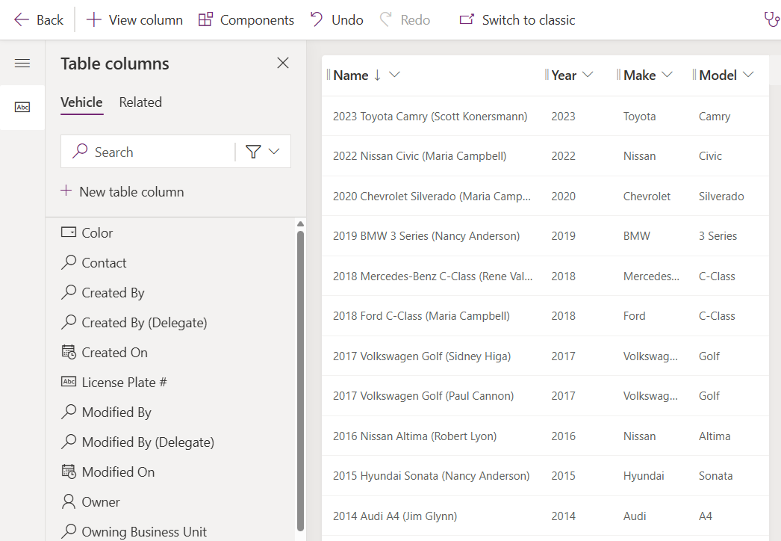

1. Switch to the Related menu and expand the Contact (Contact) table. Select the Full Name and Business Phone columns to add them to the view.

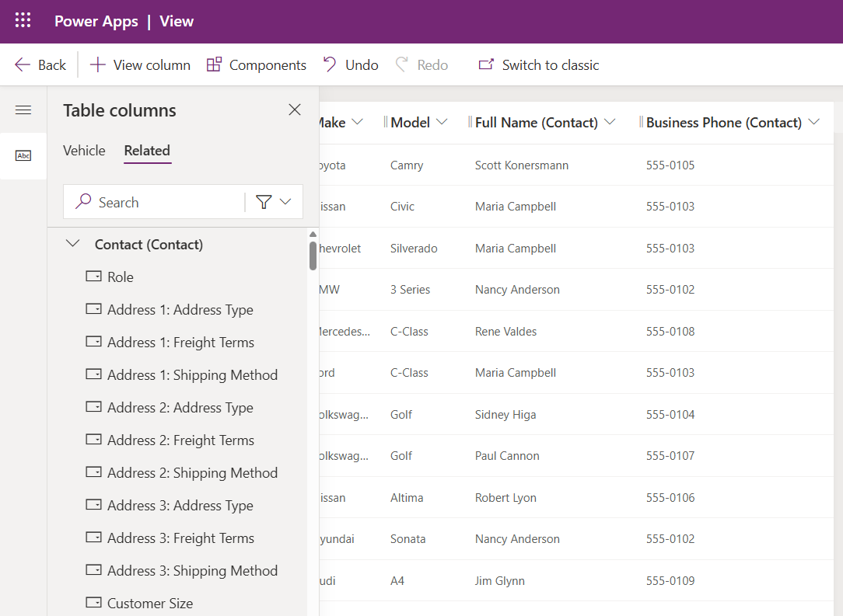

1. Sort the view by the Name column in descending order.

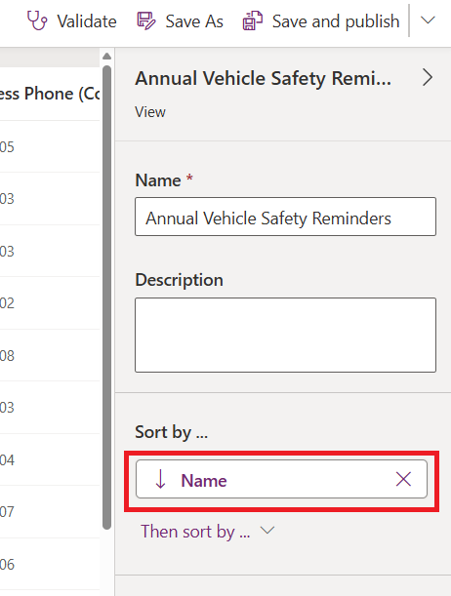

1. Open the Edit filters… menu.

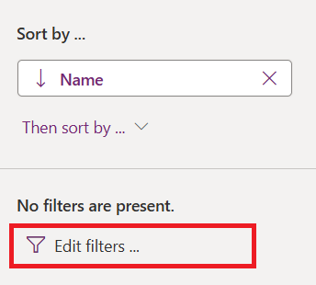

1. We want to show active Vehicles whose Registration Renewal Date is due in the next month. And we only want to call Contacts who allow phone calls. Configure the filters as follows:  
   * Status = Active
   * Registration Renewal Date = Next month
   * Contact Table
     + “Do not allow Phone Calls” = Allow

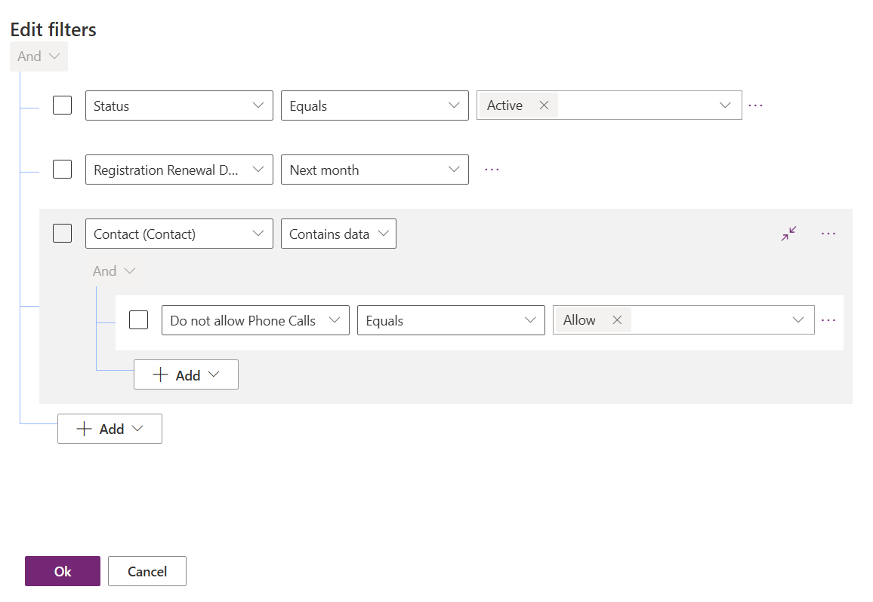

1. Save and publish the view to make the changes appear in the Model-Driven app.

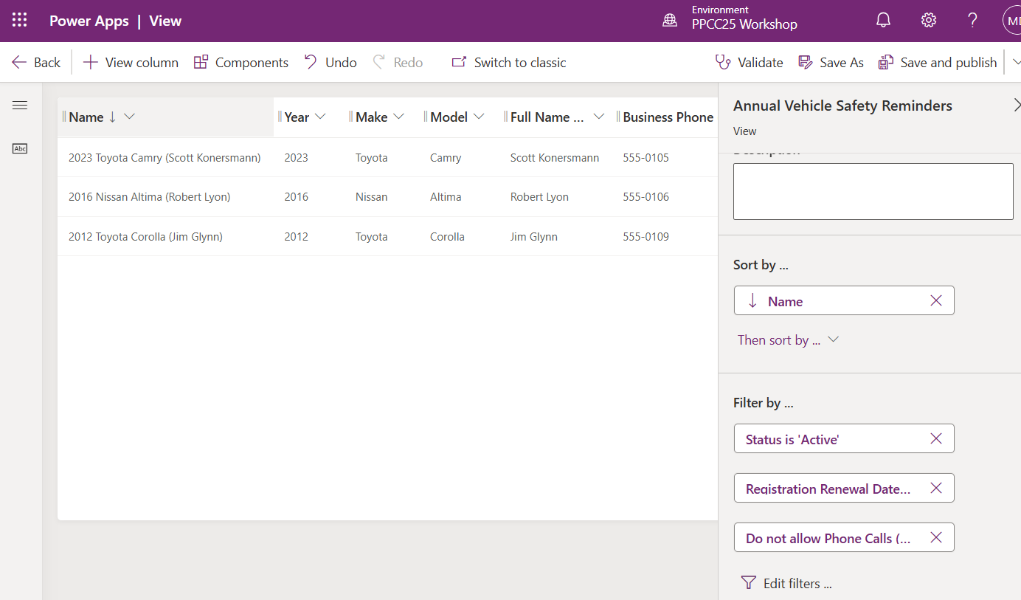

## Edit The Vehicle Main Form

Next, we want to setup the Main Form for the Vehicles table so that Model-Driven Apps users have a way to view & edit data.

1. Navigate to the Forms menu for the Vehicle table inside the Vehicle Inspections menu.
2. Edit the Main form in a new tab

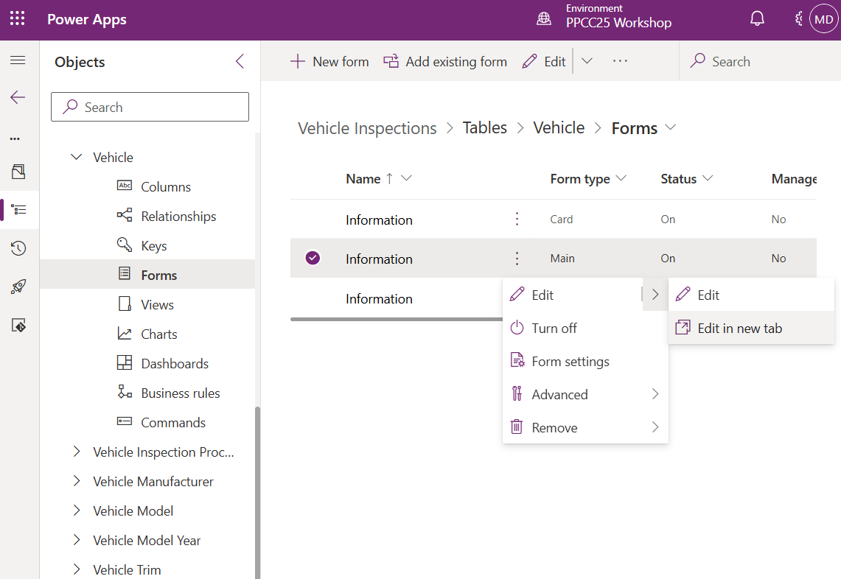

1. Select the General tab and update the Layout from 1 column to 3 columns

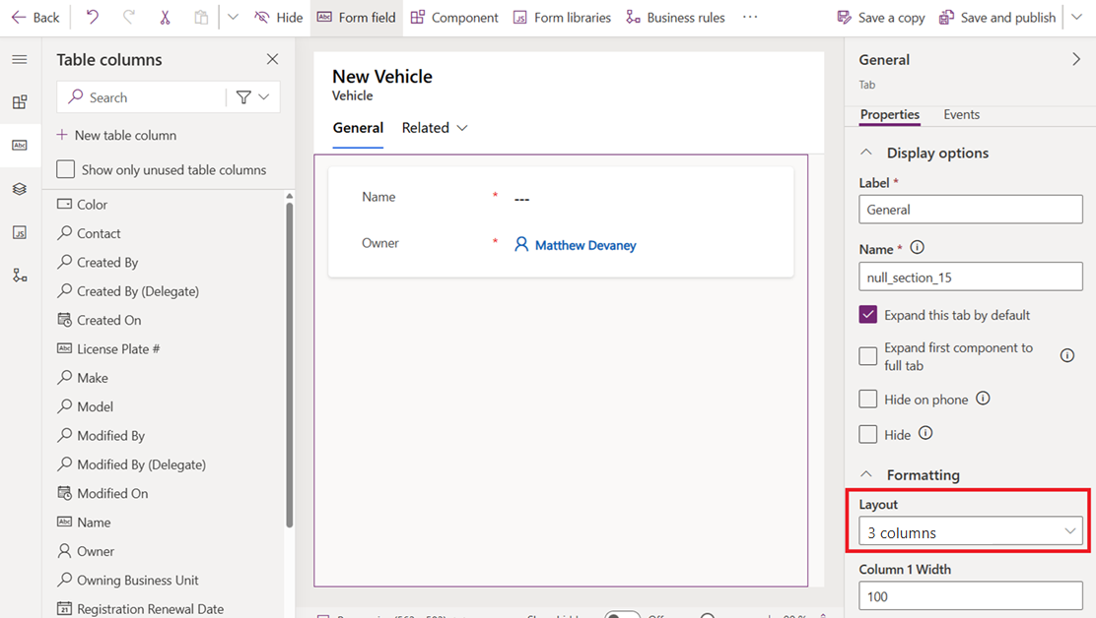

1. Select the section that contains Name and Owner. Change the label name to DETAILS.

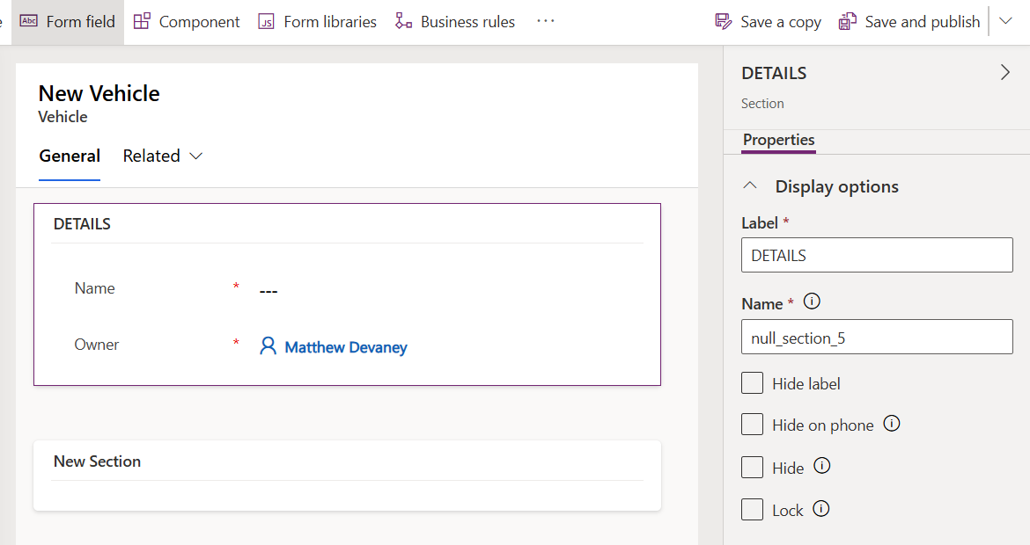

1. Move Name, Owner and Status fields to the right-column. These columns cannot be removed from the form so we will move them temporarily until we are ready to use them.

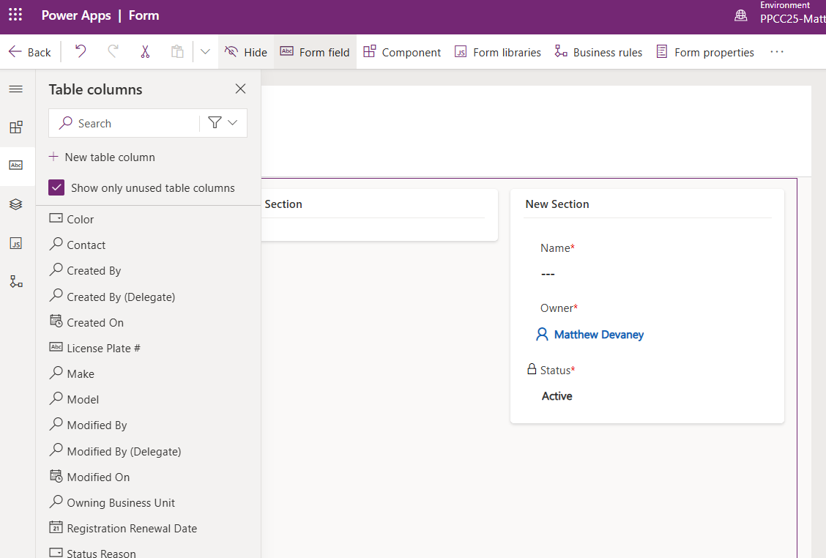

1. Add License Plate # and VIN to the DETAILS section.

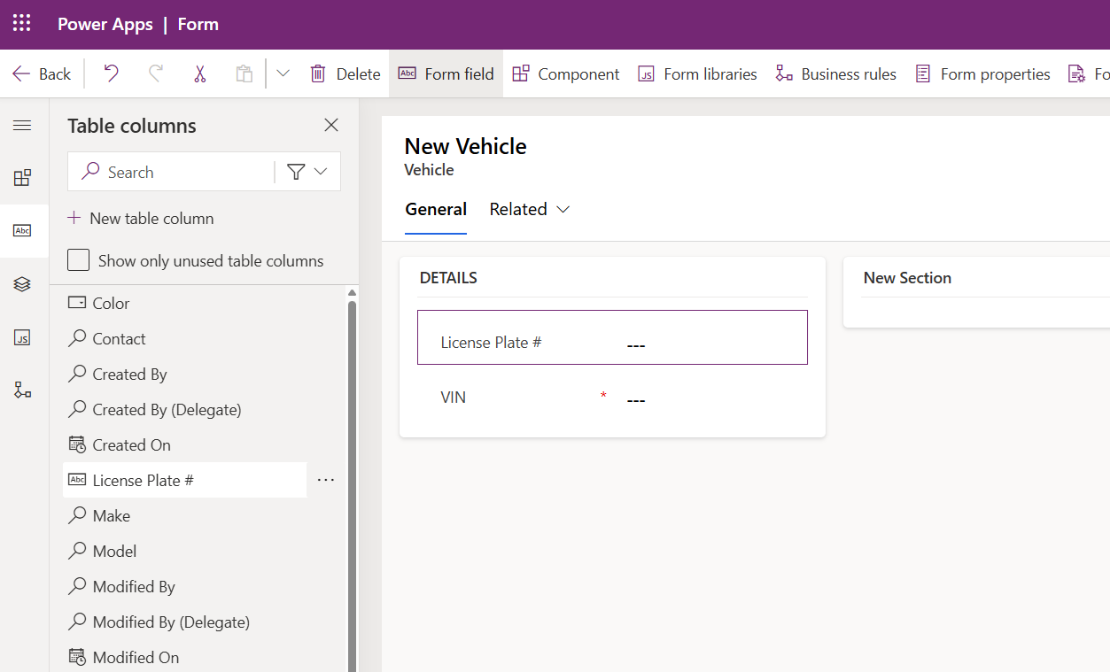

1. Add a new 1-column section named VEHICLE INFORMATION below the DETAILS section.

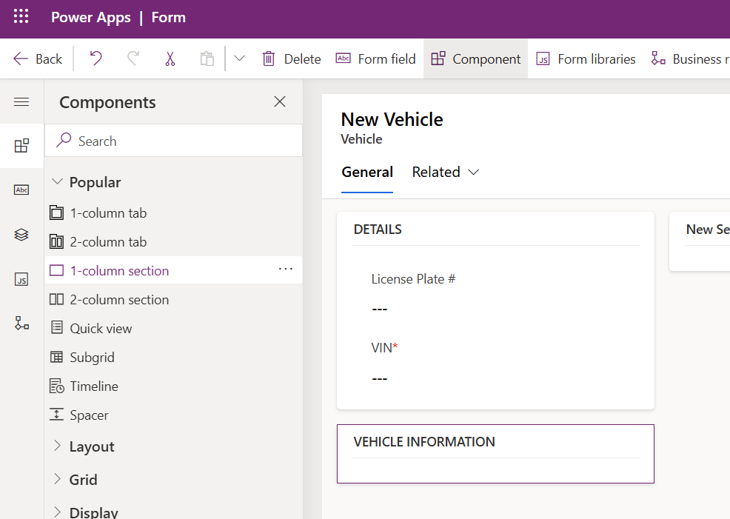

1. Insert the following fields into the VEHICLE INFORMATION section: Make, Model, Year,Trim, Color.

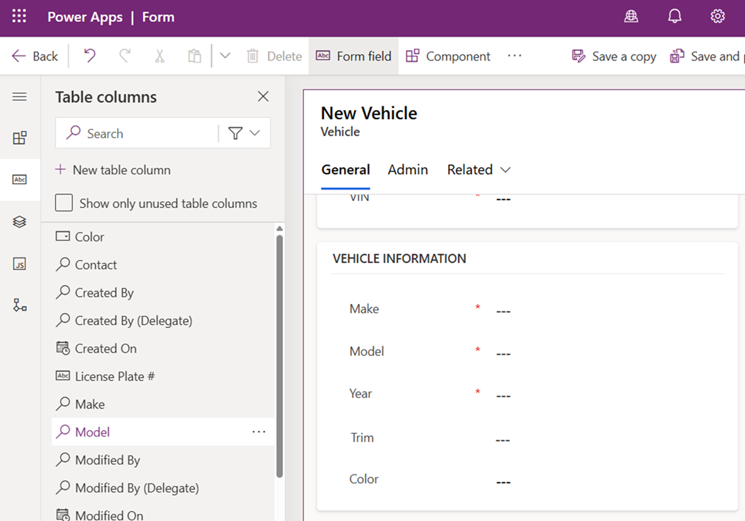

1. Rename the middle column named New Section to ADDITIONAL INFO. Include the Contact and Registration Renewal Date fields.

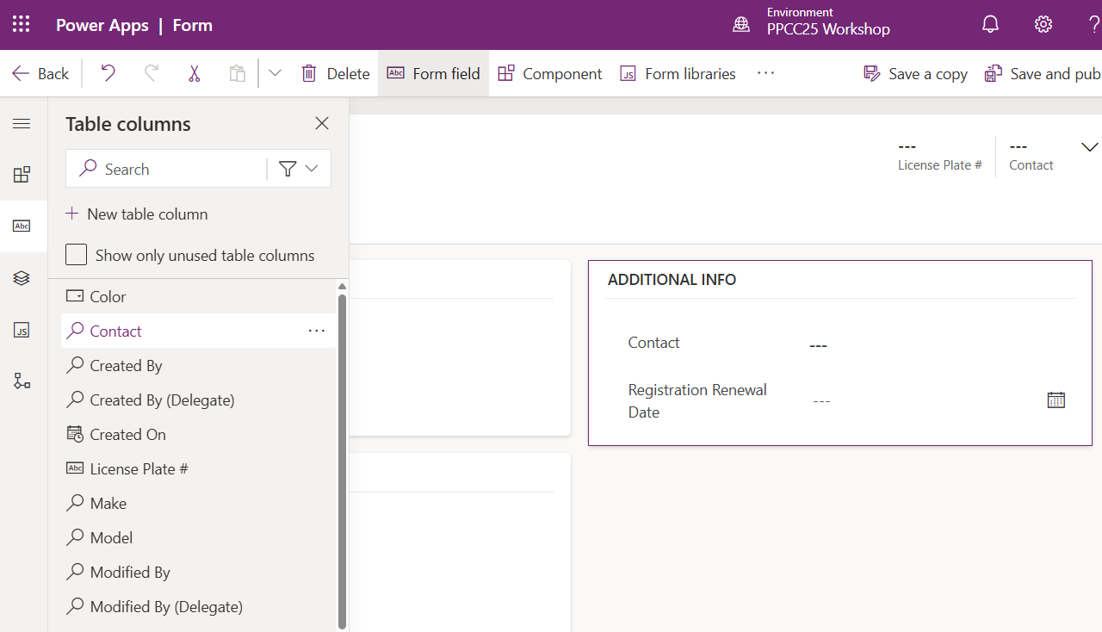

1. Insert a new 2-column tab named Admin.

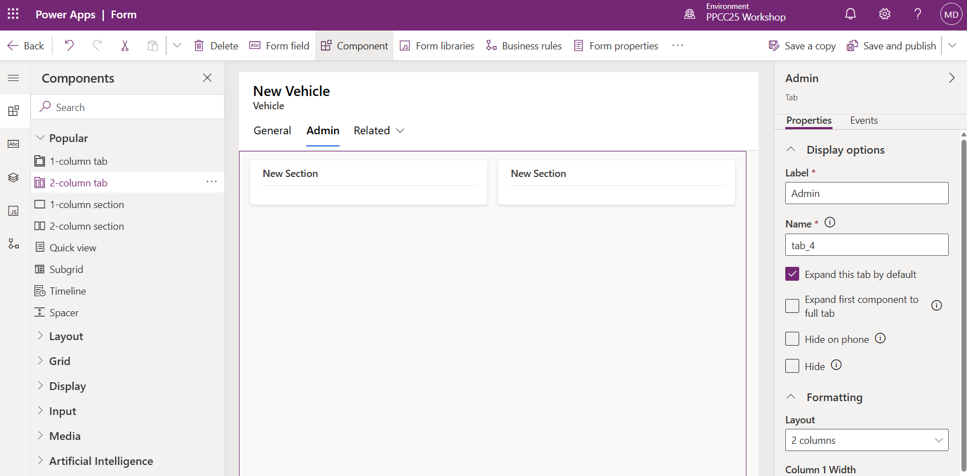

1. Update the left-column name to RECORD INFO.
2. Include the following columns in RECORD INFO: Name, Owner, Created On, Created By, Modified On, Modified By, Status, Status Reason

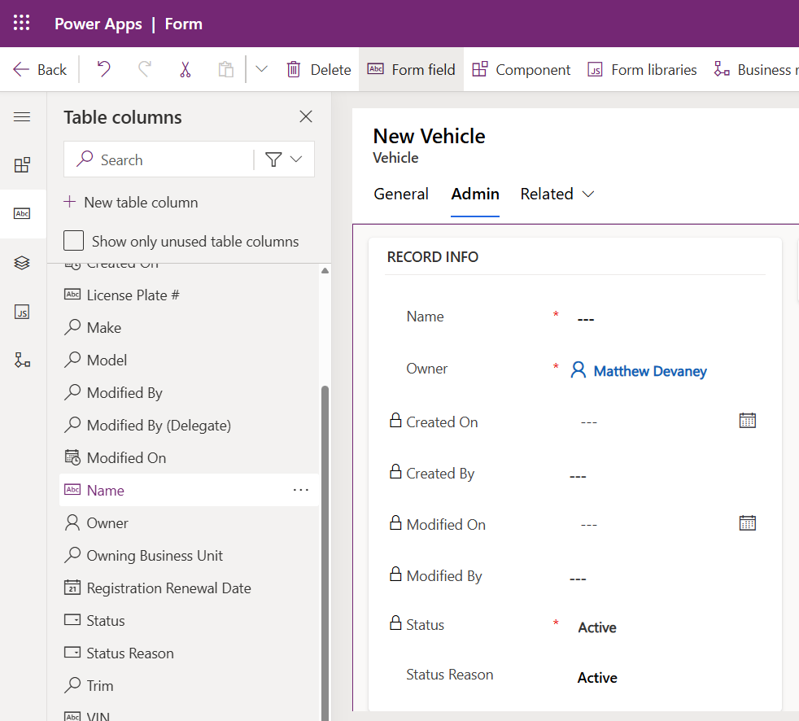

1. Select the middle column named New Section. Check the Hide option.

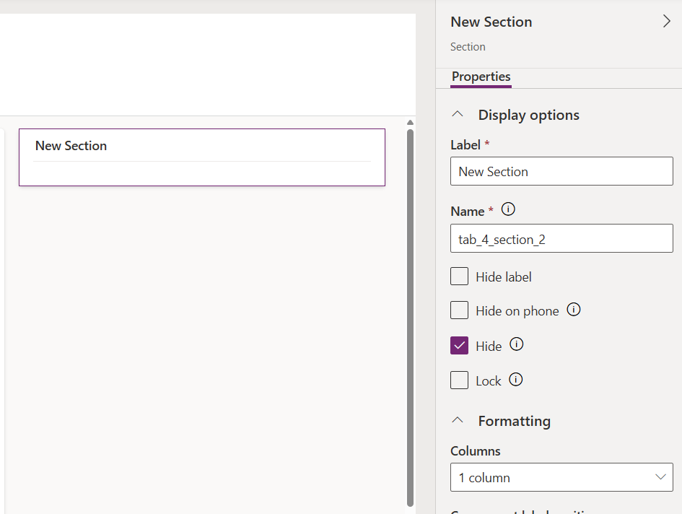

1. Select the form Header. Insert the License Plate # and Contact fields.

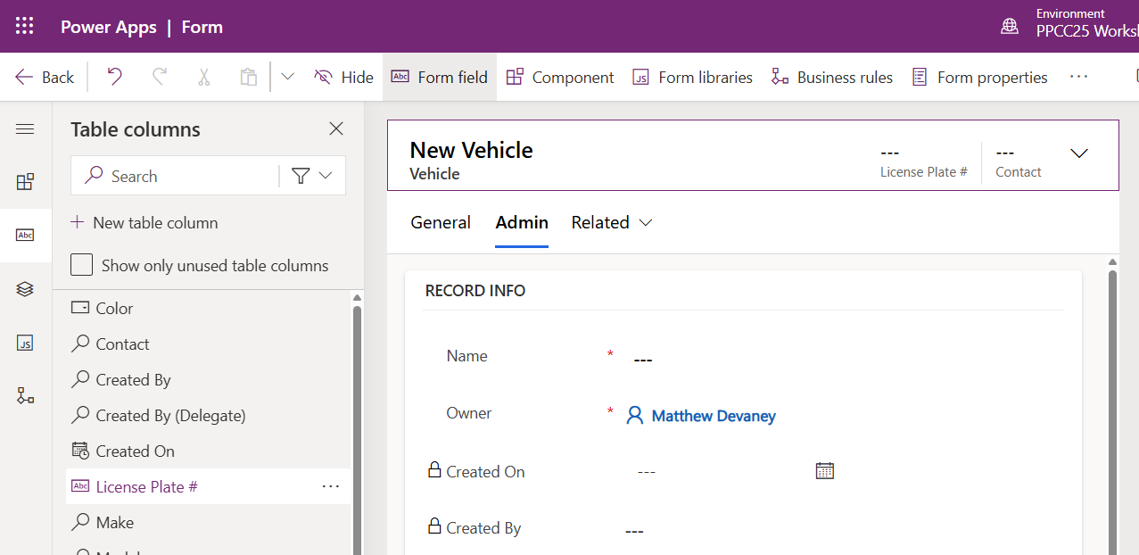

1. Review the form to ensure it looks like the screenshots below. Then Save and Publish the form.

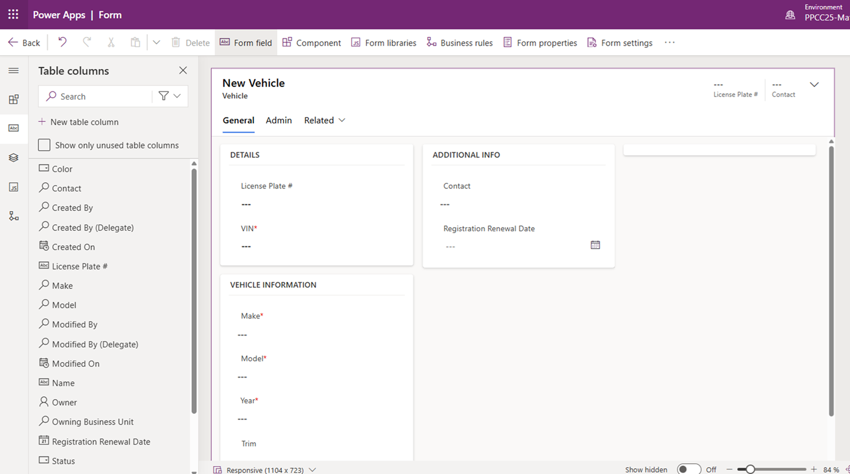

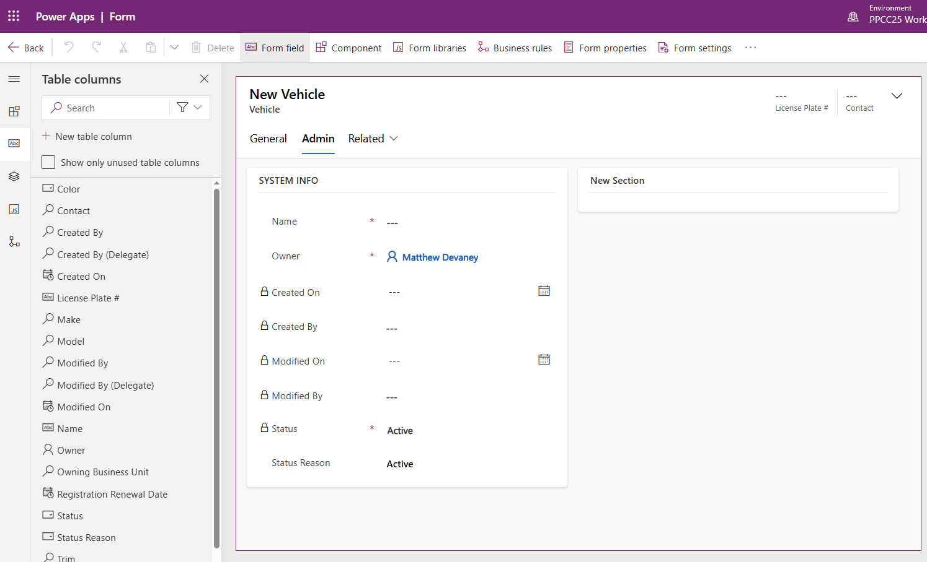

## Customize The Model Lookup Details

The Models lookup field allows the User to choose the vehicle model. We want to show additional details about the model in the dropdown.

1. Go to the Form menu for the Vehicle Model table and edit the Card form in a new table.

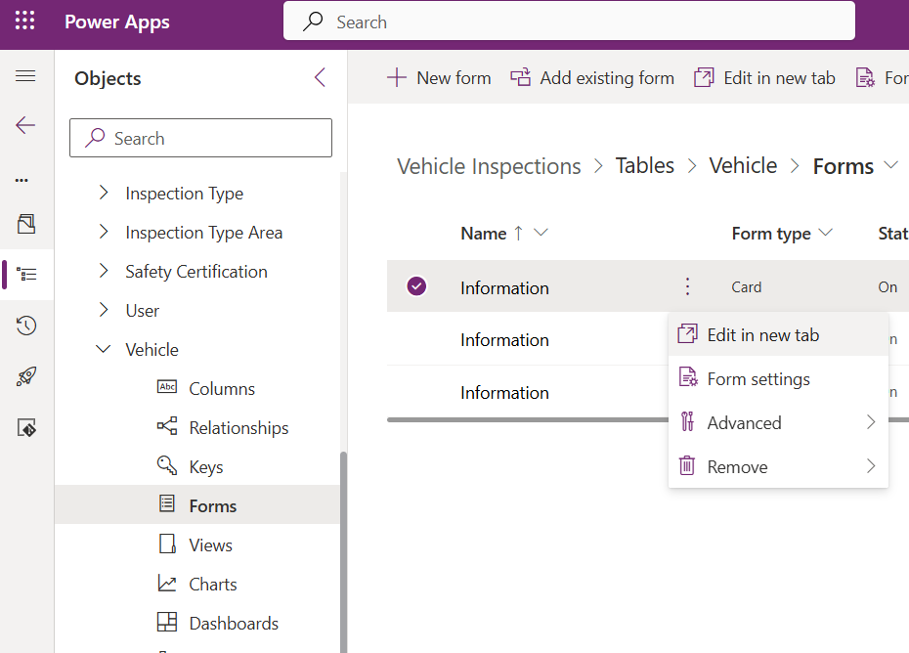

1. The Card view will appear in the classic form editor. Notice that the Details section contains the Model Name. Only fields appearing in the details section show in the dropdown menu.

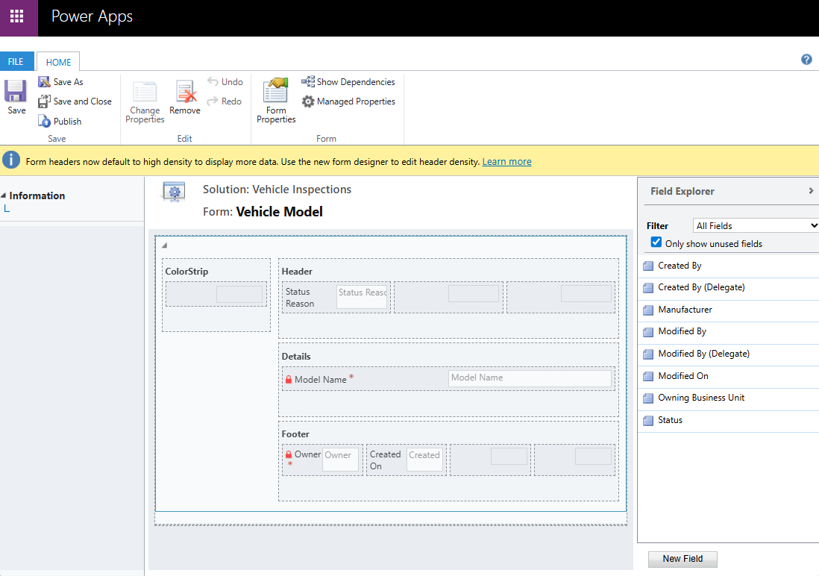

1. Add the Manufacturer field to the Details menu by selecting it from the Field Explorer menu.
2. Save the card form, then publish. Close the editor once completed.

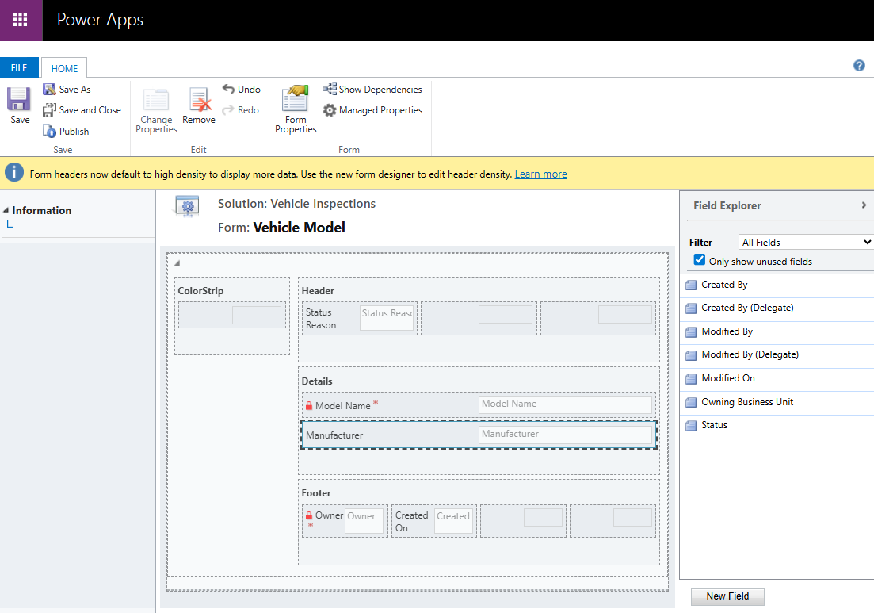

26. Open the Vehicle form for any record and select the Make field. The dropdown now includes both the model name and manufacturer.

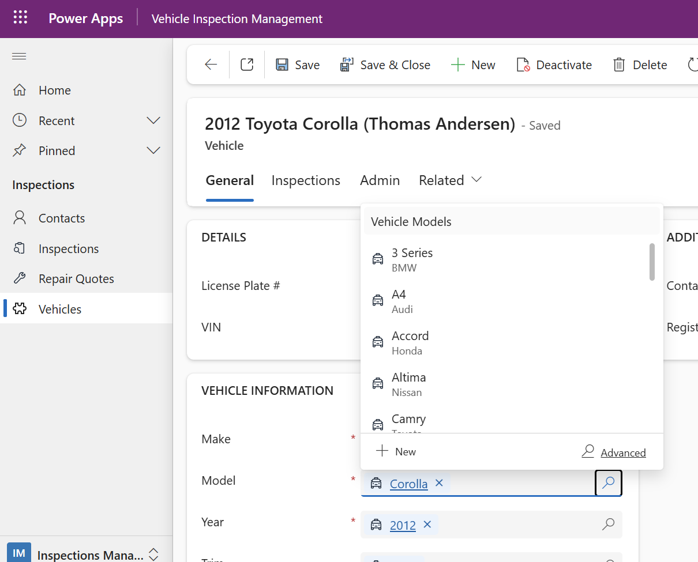

## Filter Lookup Menu Items By Related Dropdown

Make, Model, Trim and Year are related dropdowns. After the Make is selected, the Model dropdown should be filtered to only show Models for the chosen make. The same goes for Model & Trim, and Trim & Year

27. Open the Vehicle Main form and select the Model field. Check the Filter by related rows option. Select these settings:

* Relationship to current table: Make
* Relationship to this lookups table: Manufacturer

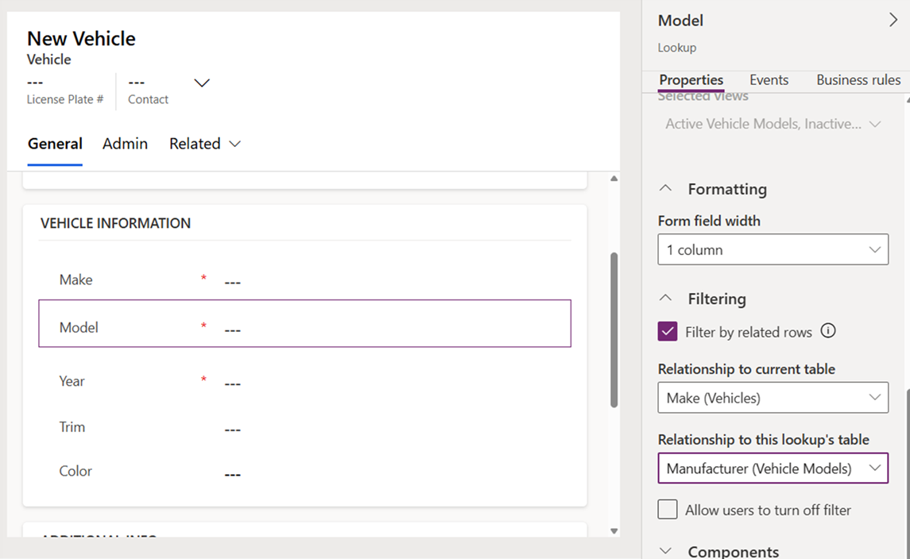

28. Select the Trim field. Check the Filter by related rows option. Select these settings:

* Relationship to current table: Model
* Relationship to this lookups table: Model

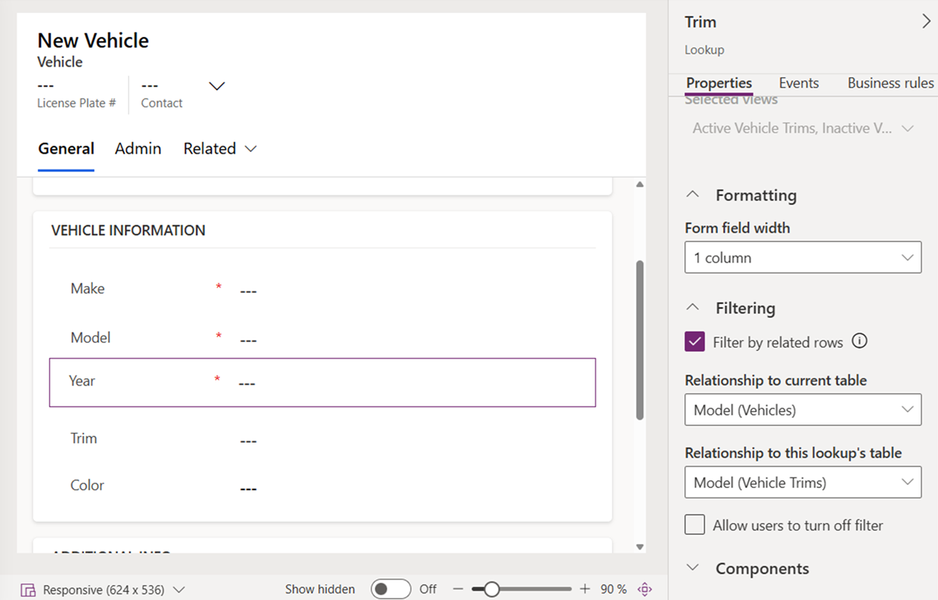

29. Select the Trim field. Check the Filter by related rows option. Select these settings:

* Relationship to current table: Trim
* Relationship to this lookups table: Vehicle Trims

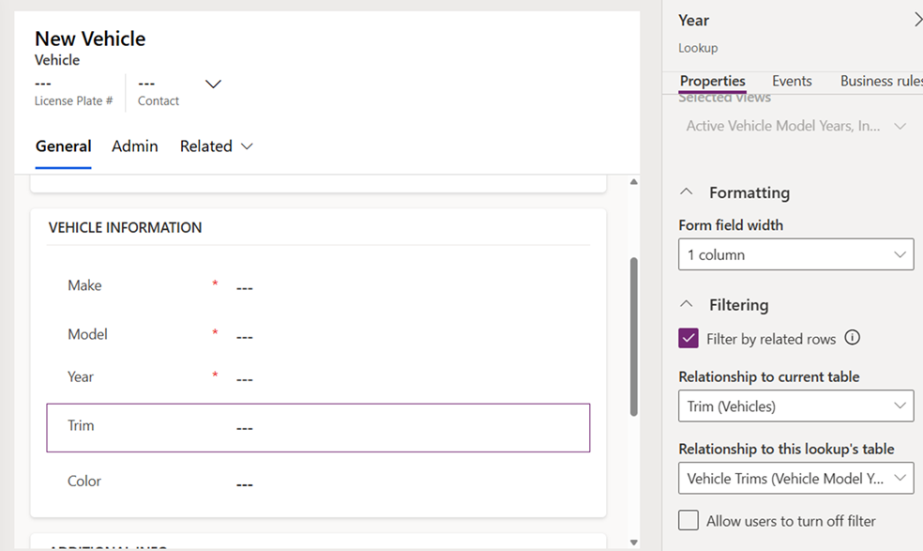

1. Save and publish the form
2. Open any Vehicle the Vehicle Inspections Management app. The dropdowns menus are now filtered.

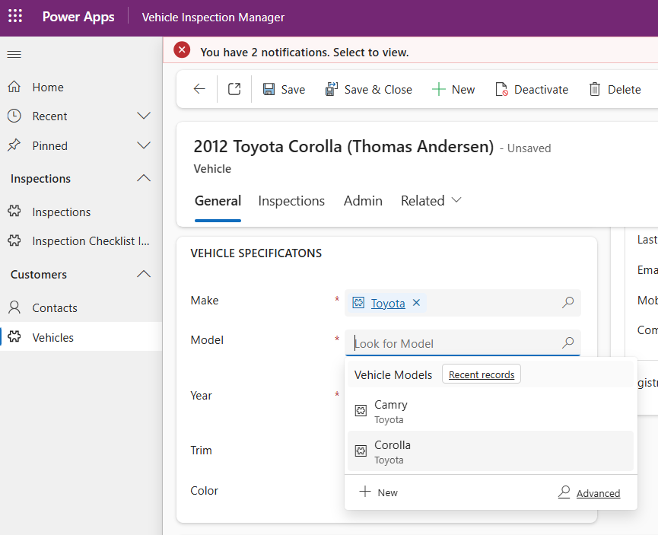

## Add A Sub-grid Of Recent Inspections

We want to give anyone browsing a Vehicle record a quick way to see all of its past inspections. To do this we will create a new sub-grid.

1. Add a new 1-column tab named Inspections to the Vehicle Main form.

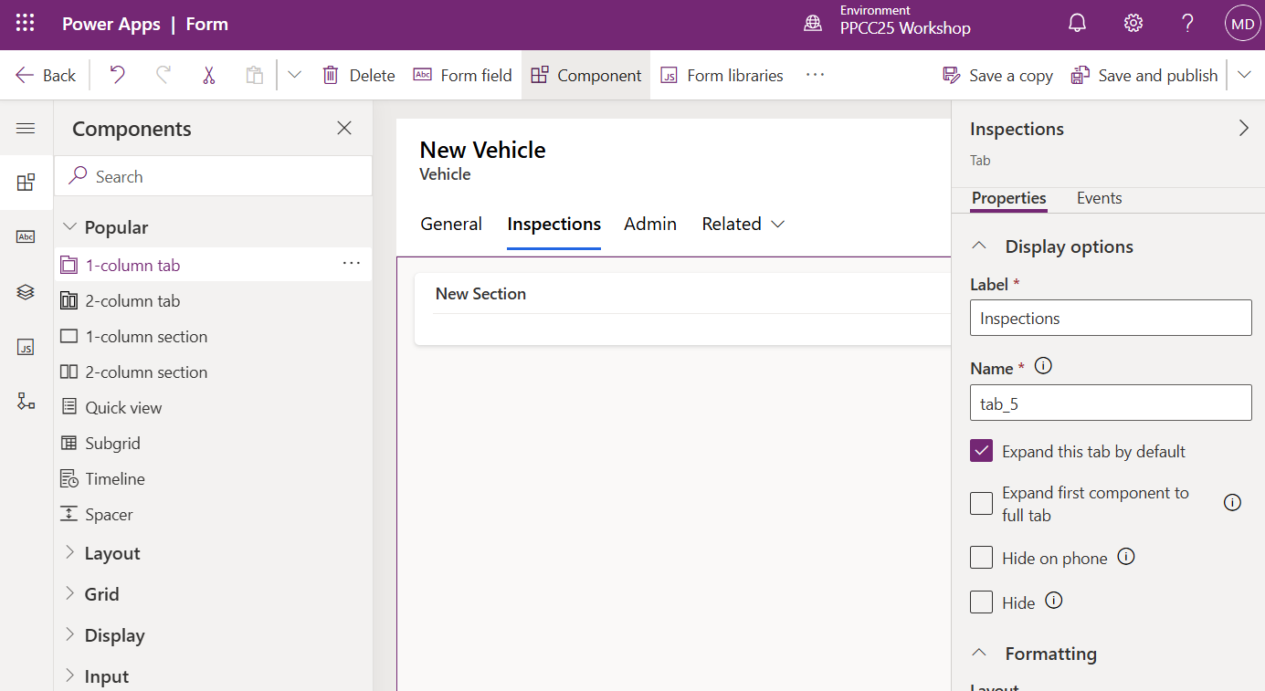

1. Insert a sub-grid into the New Section. Check Show related records. Select the Inspections table and the Active Inspections view.

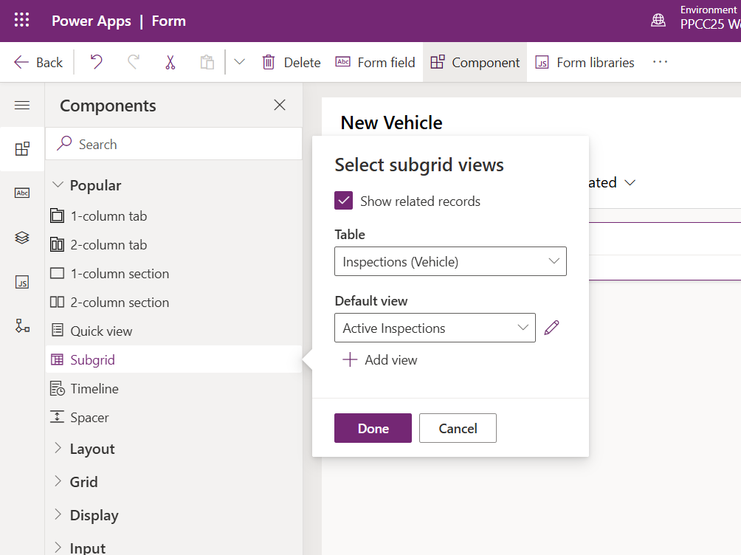

1. Label the sub-grid RECENT INSPECTIONS.

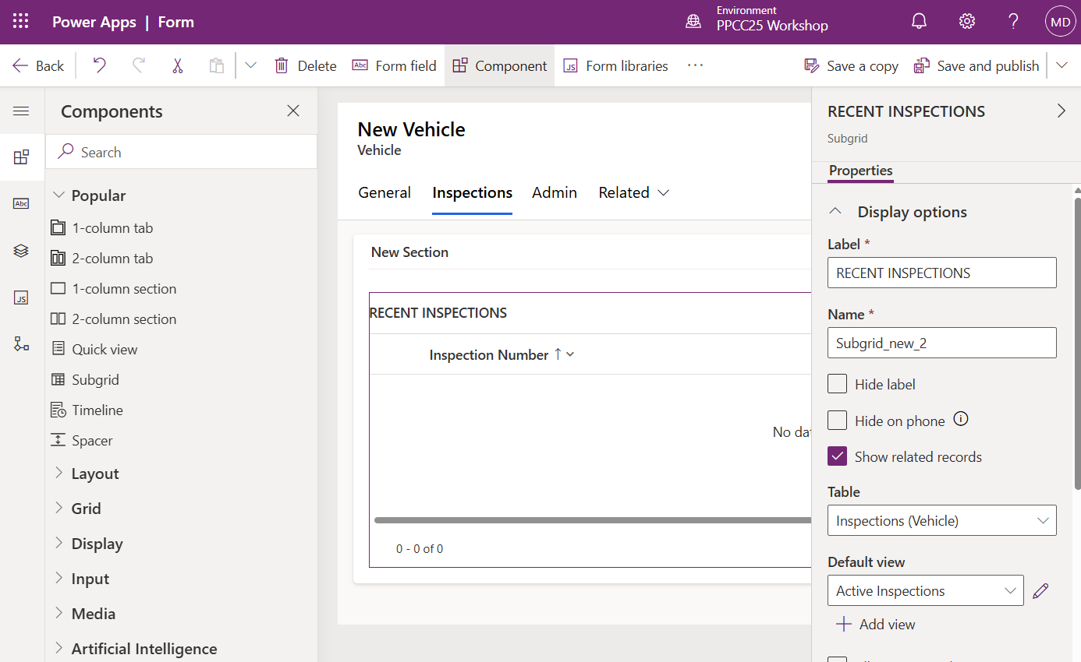

1. Set the sub-grid maximum number of rows to 10.

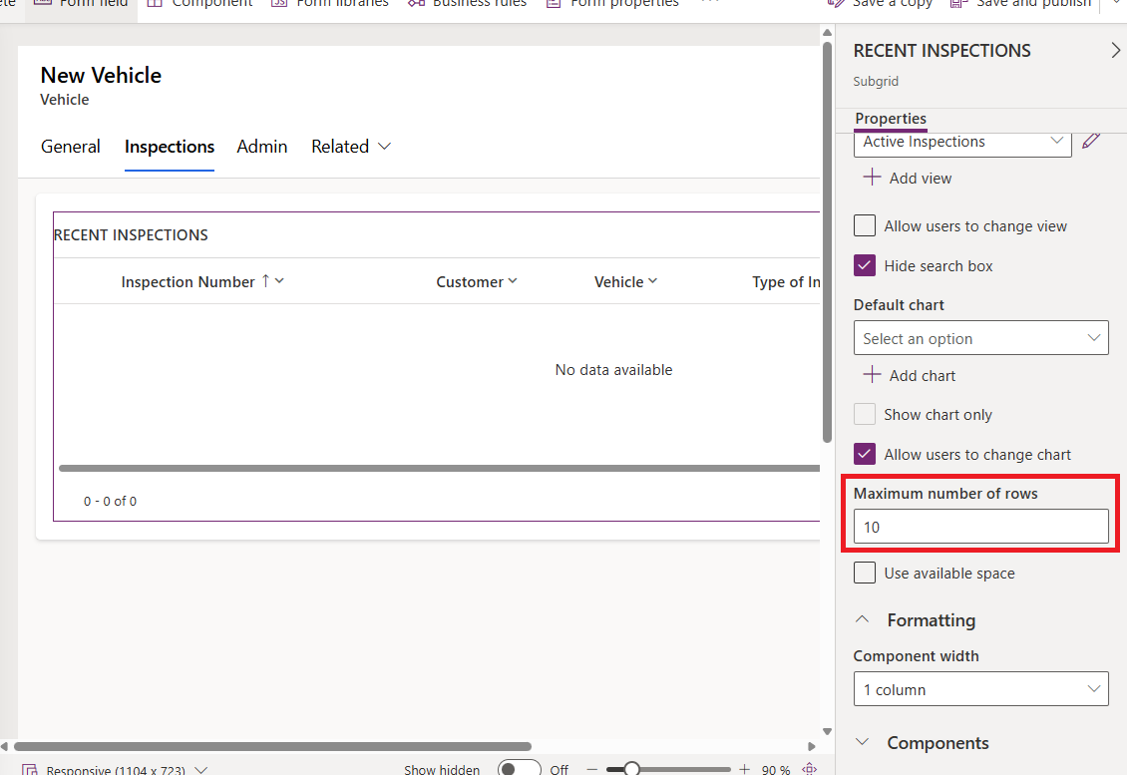

1. Hide the label for New Section.

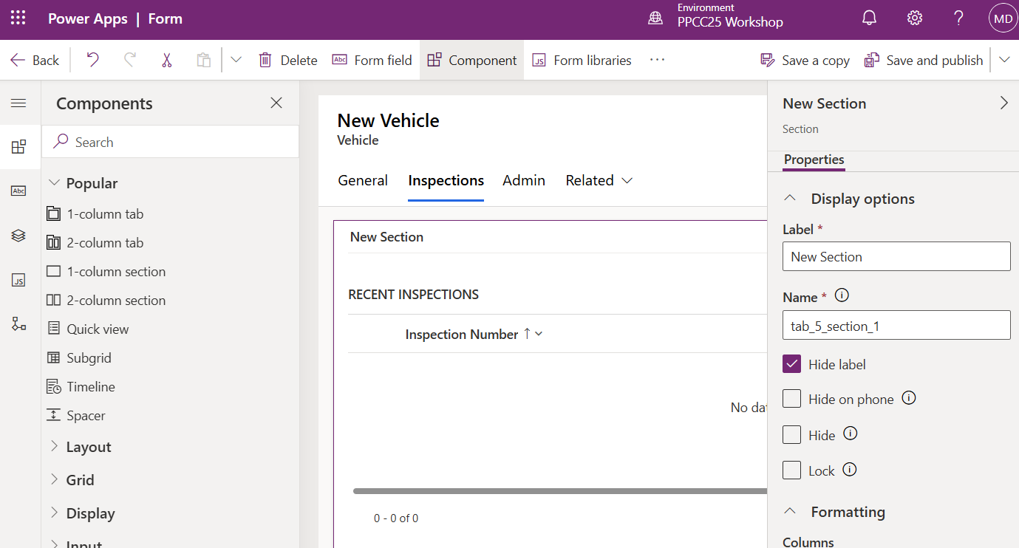

1. Save and publish the form.

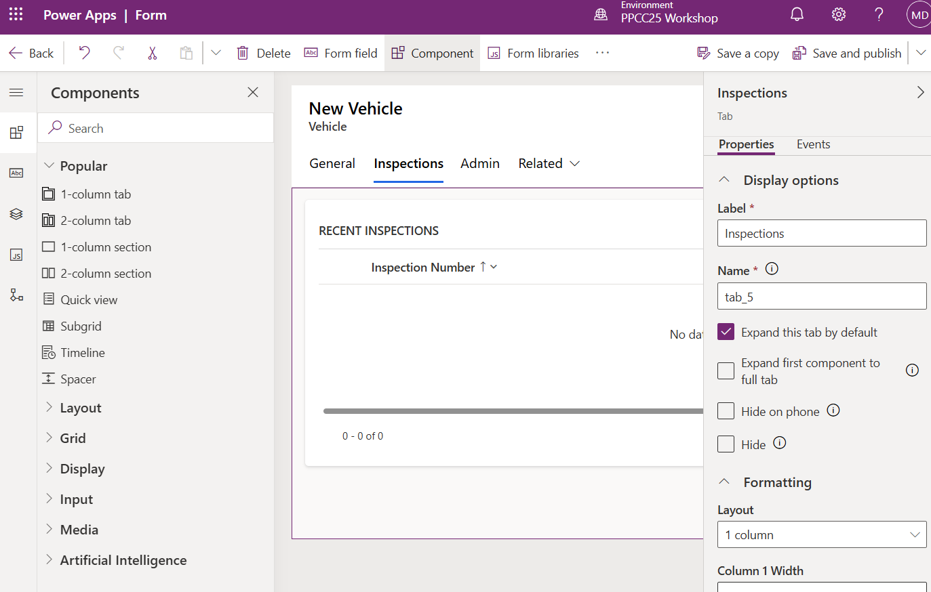

1. Open any Vehicle record and navigate to the Inspections tab. The sub-grid will show a list of the most recent related inspections.

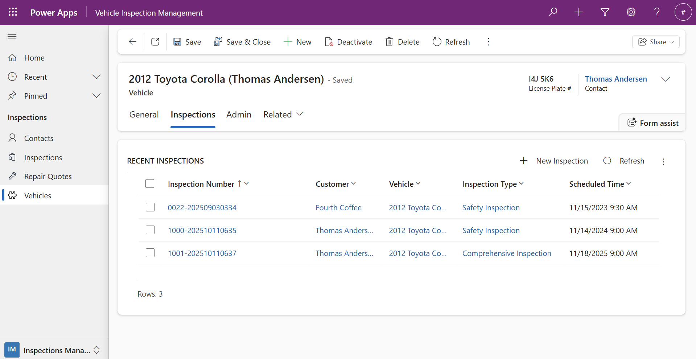

## Insert A Timeline Control Into The Vehicle Form

A user might want the ability to make a note on the vehicle record. To do this we will add a timeline control.

1. To add a timeline control to a form the enable attachments setting must be checked. This setting is already checked for the table, and no action is needed.

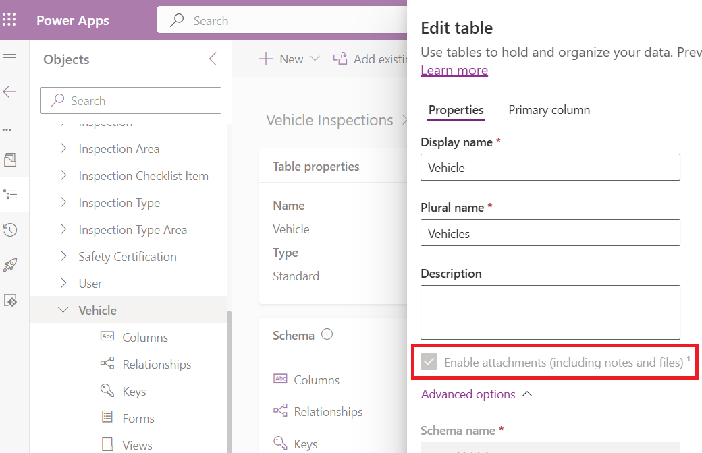

1. Insert a new Timeline control into the Vehicle Main form. Check the record types to show Activities and Notes.

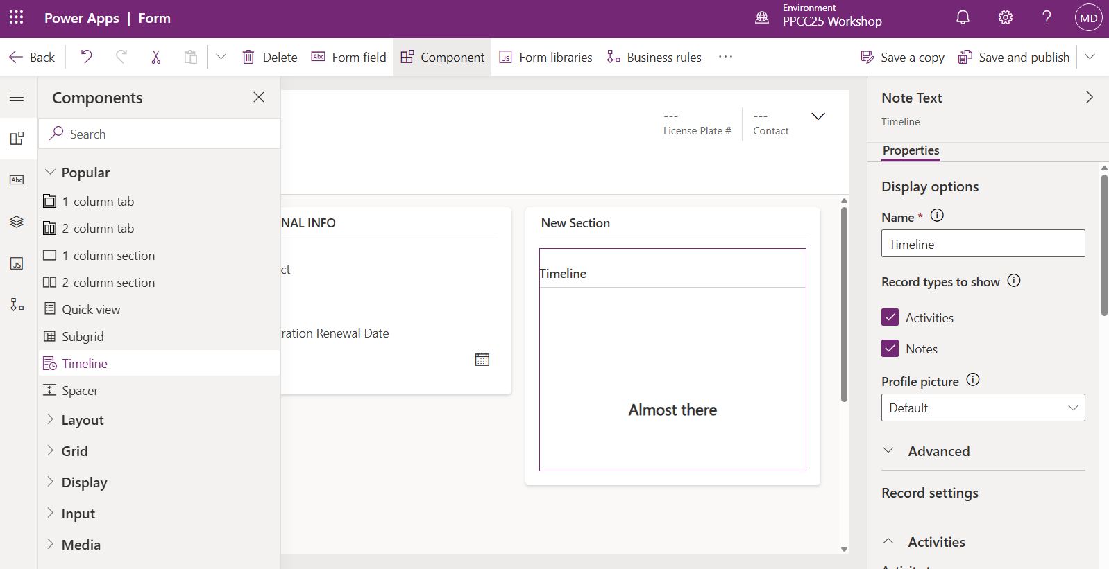

1. Enable only the following Activity Types: Appointment, Email, Phone Call, Task
2. Save and publish the form.

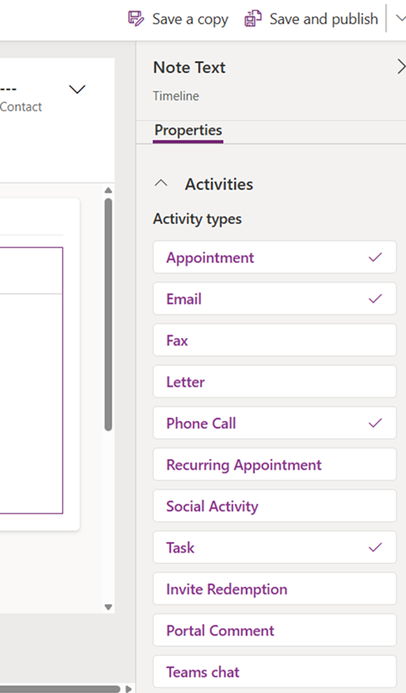

1. Select the section named New Section. Then check Hide label. Save and publish the form.

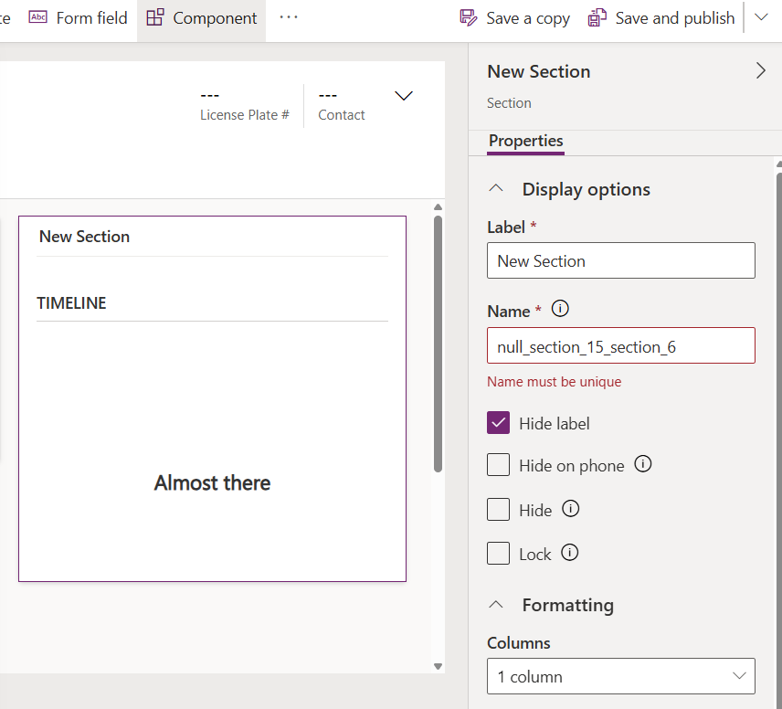

1. Open any Vehicle record in the Vehicle Inspections Management app. The timeline control now appears on the right side of the form.

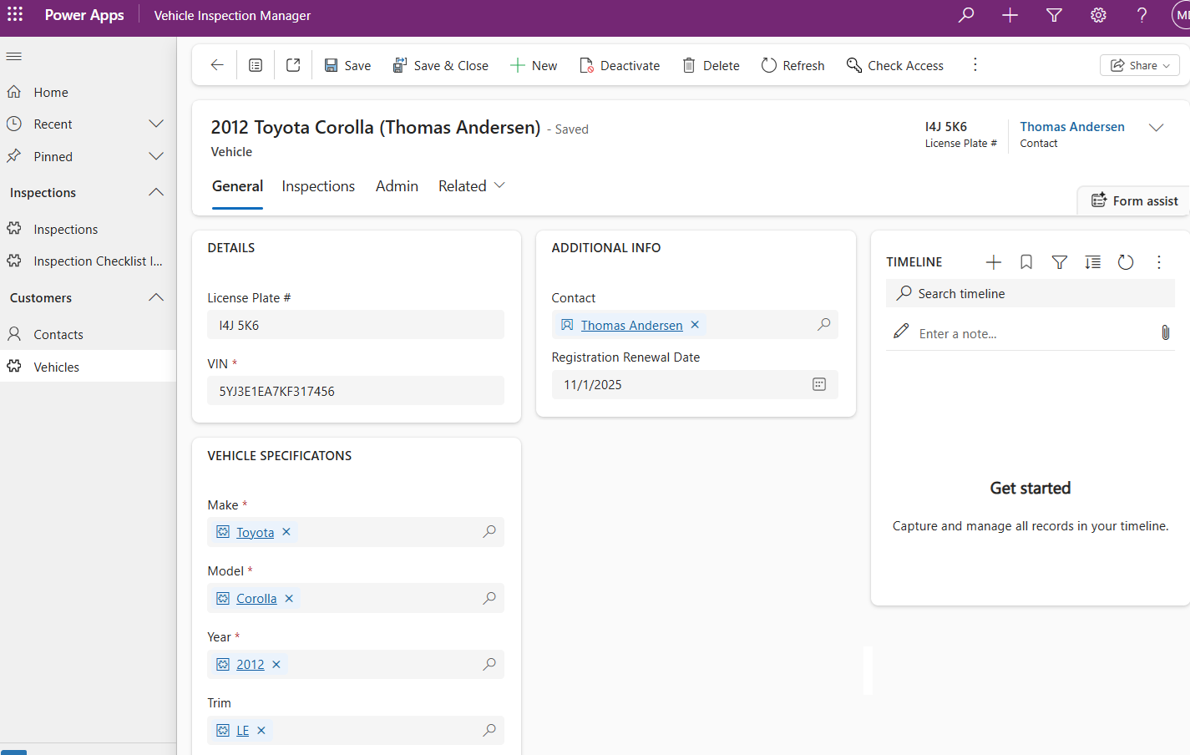

1. Create a new note in the timeline.

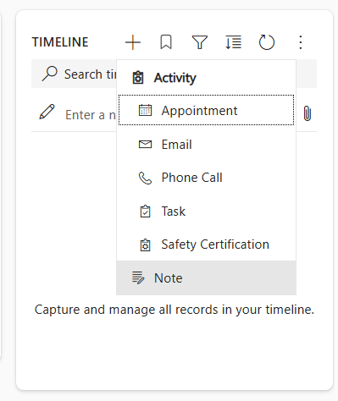

1. Give the note a title and write a description. Optionally, attach a file. Then press the Add note and close button.

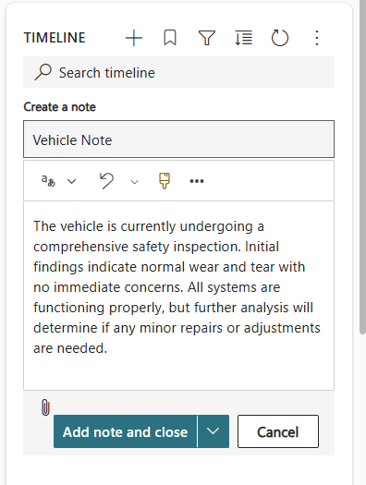

1. The note appears in the timeline.

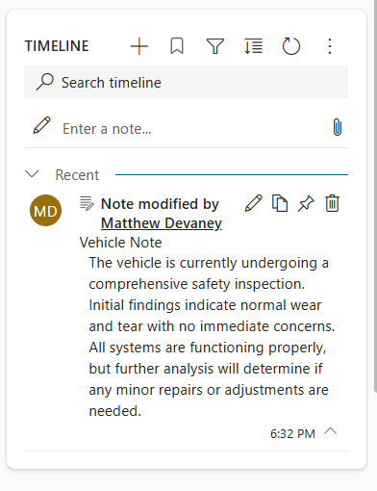

## Create A Custom Safety Certification Activity Type

The timeline can be customized to include more activity types than the default options. We will create a new activity type named Safety Certification

1. Go to the Vehicle Inspections solution and create a new table named *Safety Certification*. Choose the Type *Activity*. Then press Save.

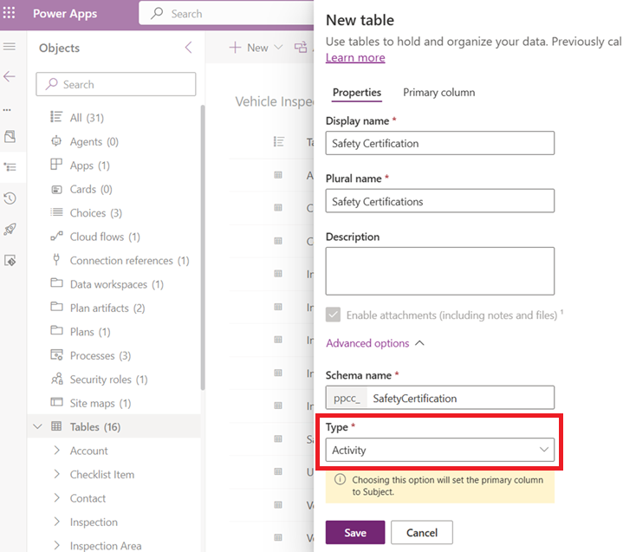

1. Add a choice column named Outcome.

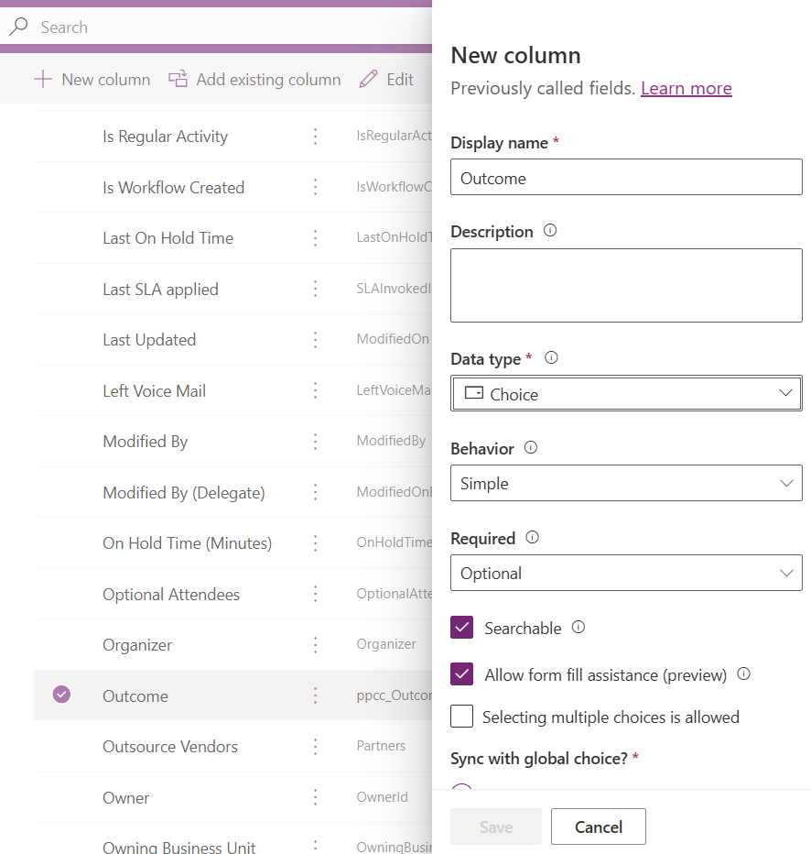

1. Choose Sync with global choice, then Sync this choice with Passed, Failed. Save the Outcome column.

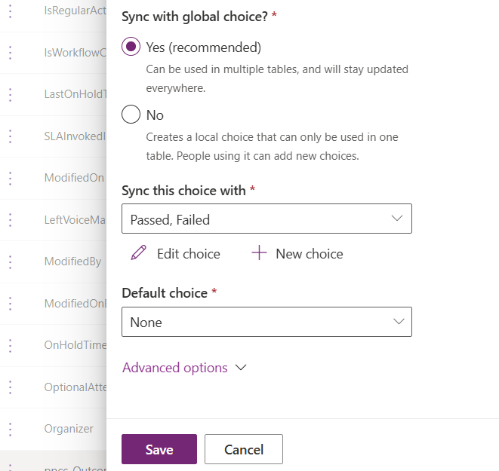

1. Edit the Main form for Safety Certification in a new tab.

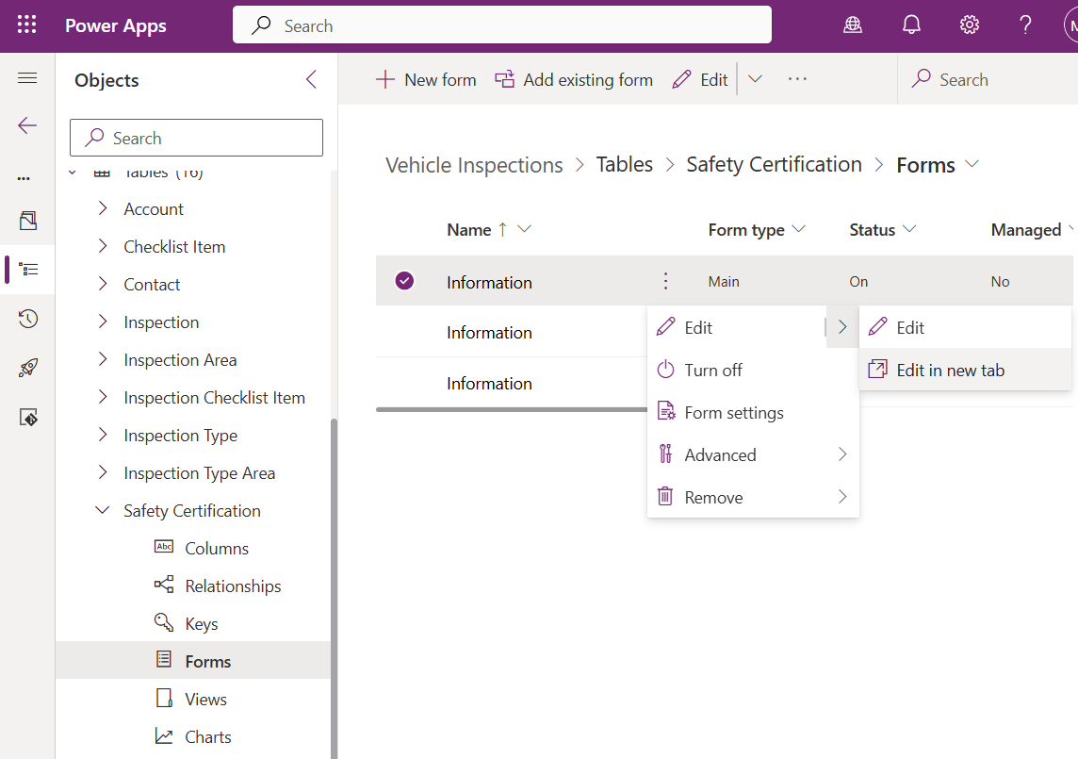

1. Add the Outcome field to the Main form underneath Subject. Save and publish the form.

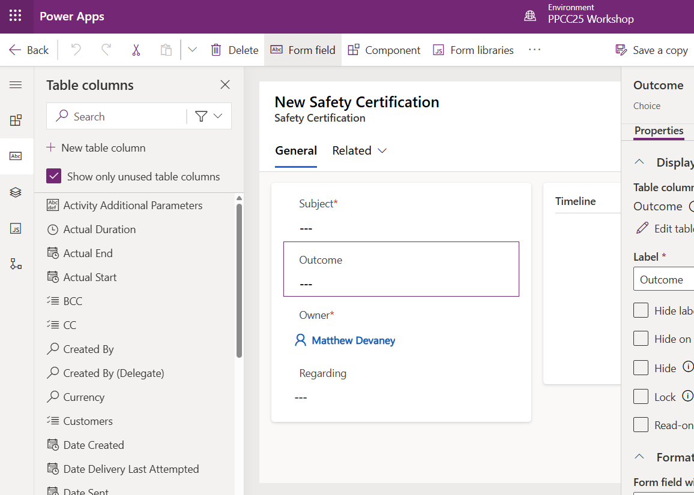

1. Open the Safety Certification card form in a new tab.

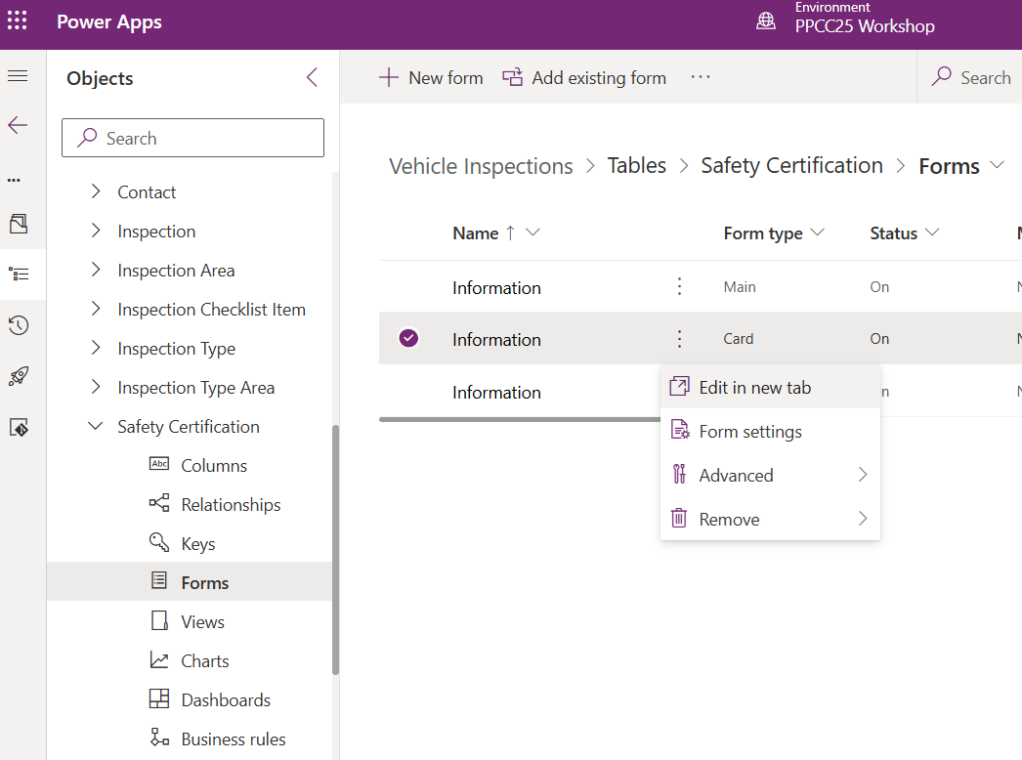

1. Insert the Outcome field below Subject. Save, close and publish the form.

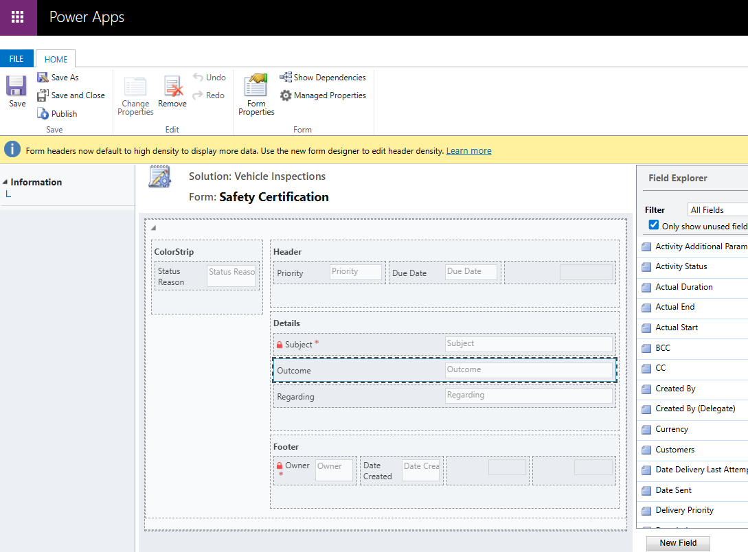

1. Go to the Vehicle main form. Select the timeline control. Enable the Safety Certification activity. Save and publish the form.

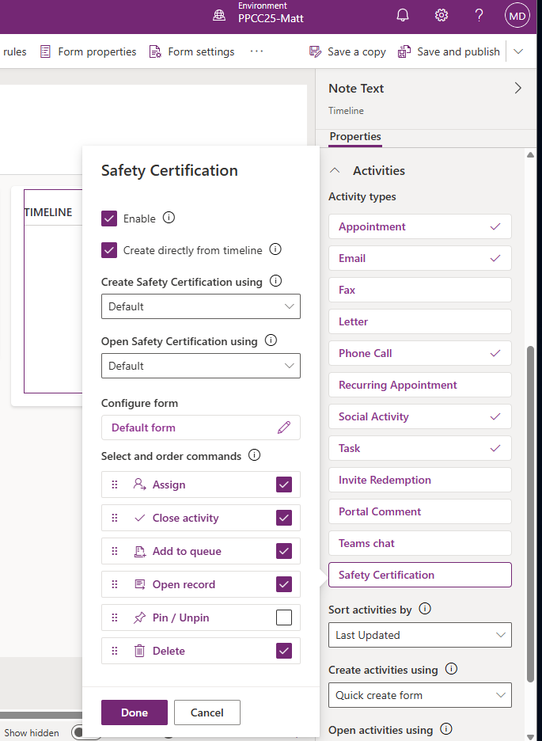

1. Go to the Vehicle Inspections Management app and open any Vehicle record. Add a new Safety Certification.

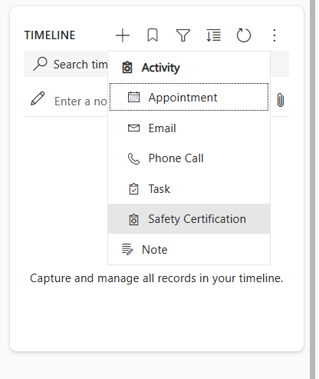

1. Fill-in the new Safety Certification Subject and Outcome then press Save & Close.

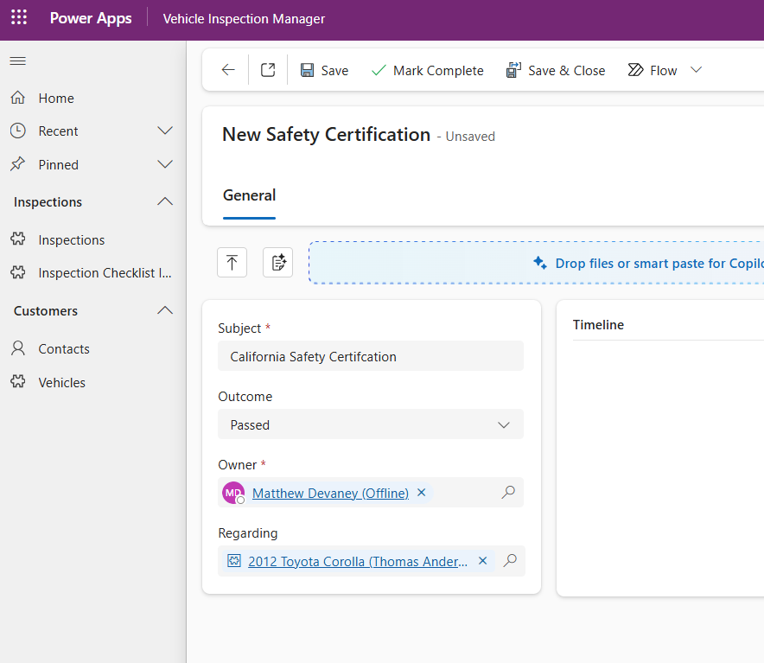

1. The Safety Certification activity appears in the timeline as a new activity.

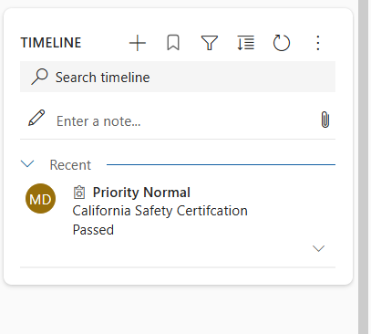

## Display Related Record Details In A Quick-View

The vehicle record form includes a Contact field for the owner of the car. We will a quick-view form to show the Contact’s business phone number and email which is stored on the related record.

1. Open the Vehicle main form and add a new Quick View component below the Contact field. Choose the Contact lookup field and the account contact card form.

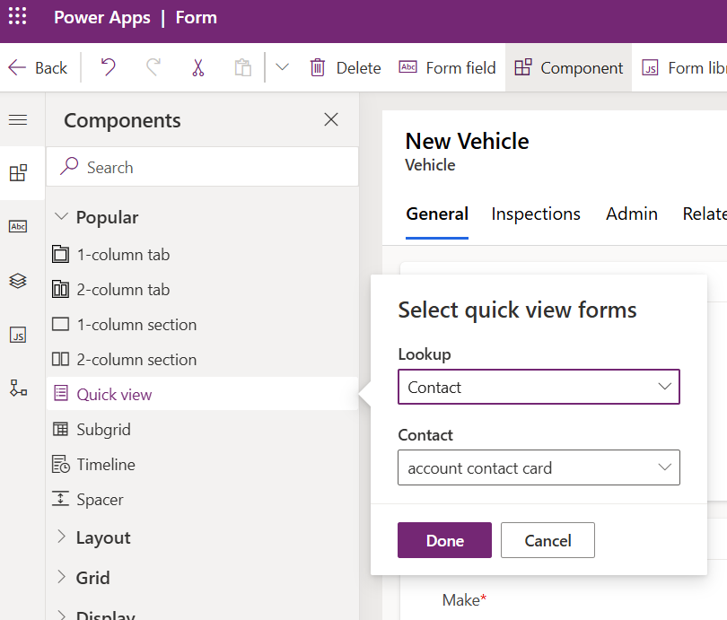

1. The quick view form appears on the form and includes Email and Business fields. Save and publish the form.

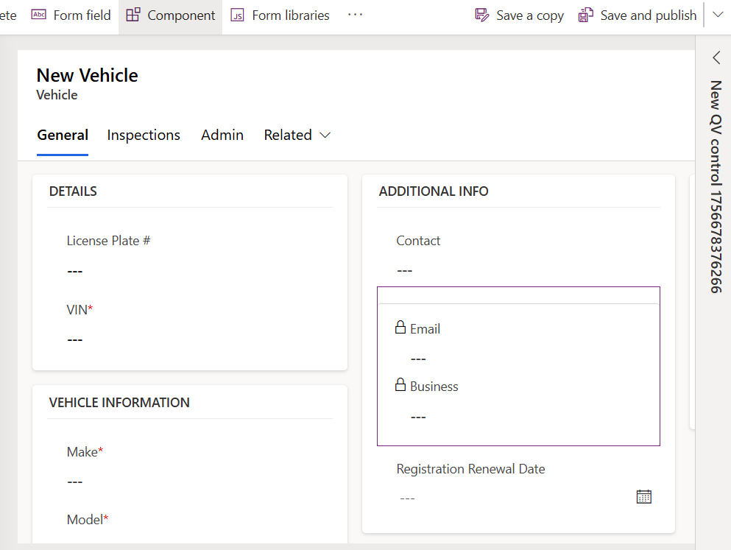

1. Open any vehicle record in the Contact form to see related record information in the quick-view form.

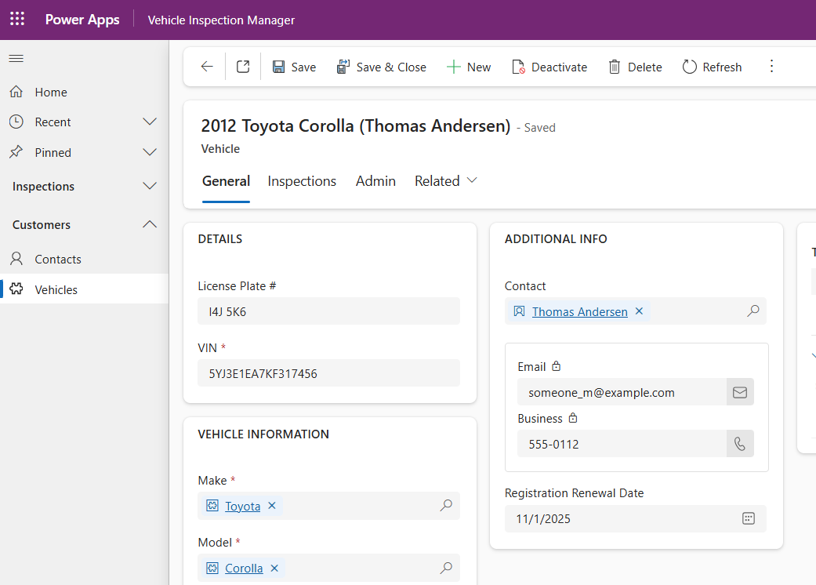

## Change The Icon For A Table

We want to include a custom icon for the Vehicles table to replace the default icon.

1. In the Vehicle Inspections solution, go to the Web Resource image named Car. This is the icon we will use in our application. Close the web resource.

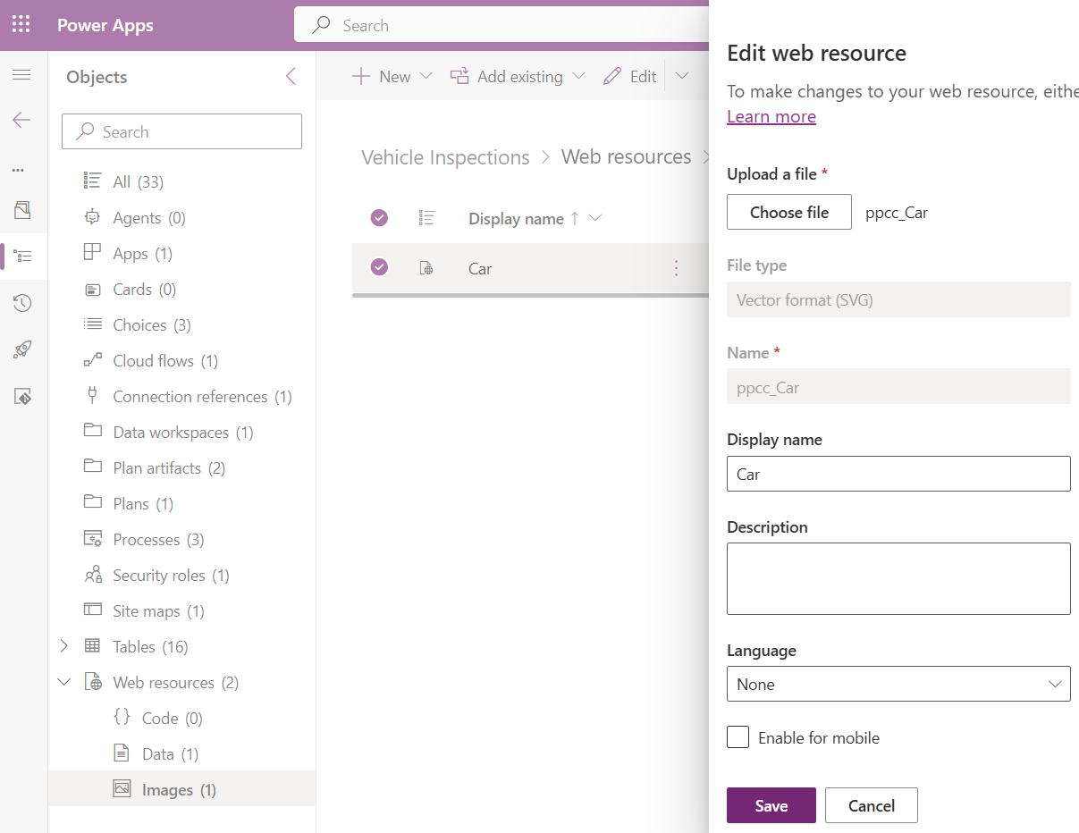

1. Open the Vehicle Inspection Management model-driven app.

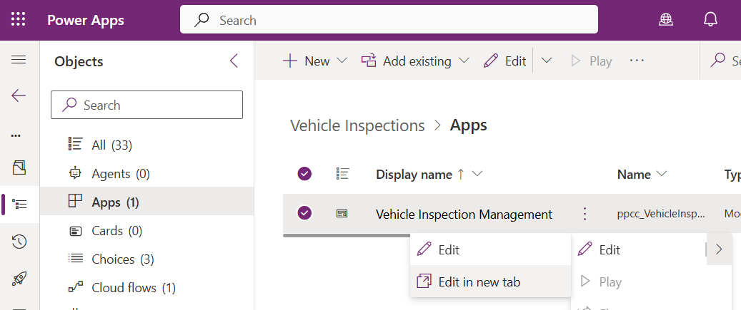

1. Select the Vehicle table, then choose the settings tab on the right-side menu. Update the icon dropdown to use web resource and press the Select icon button.

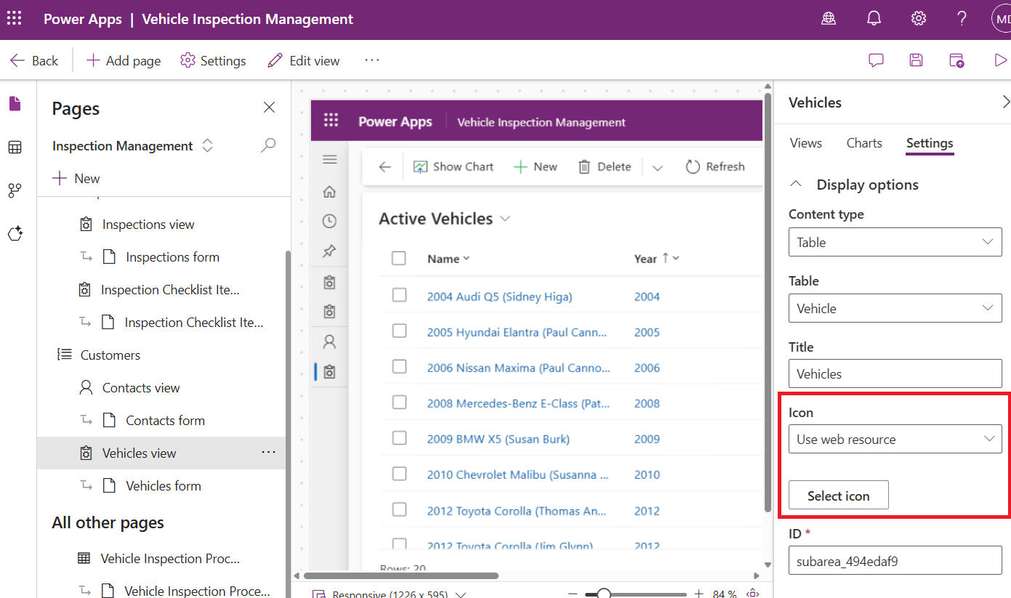

1. Choose the Car icon and press the Apply button.

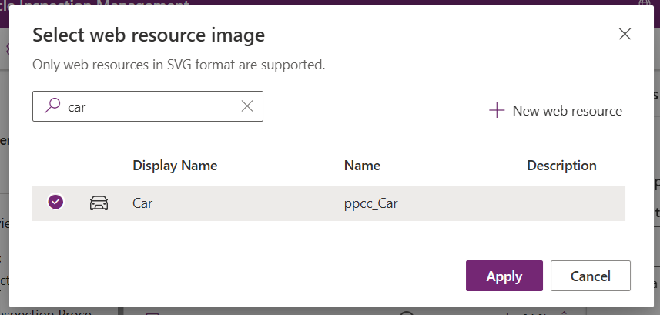

1. Save and publish the app. The Vehicles page now shows a car icon.

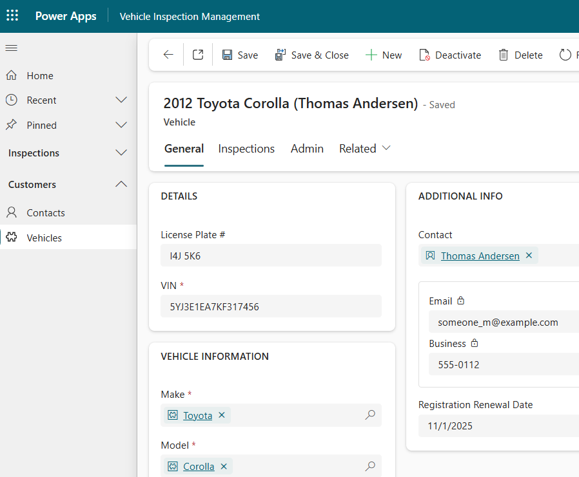

## Create An Inspections Bar Chart

Charts and views are the basic components needed for a dashboard. We will create a simple bar chart for inspections. Then we will add it to a dashboard.

1. Go to the Inspection table, navigate to Charts then press the New Chart button.

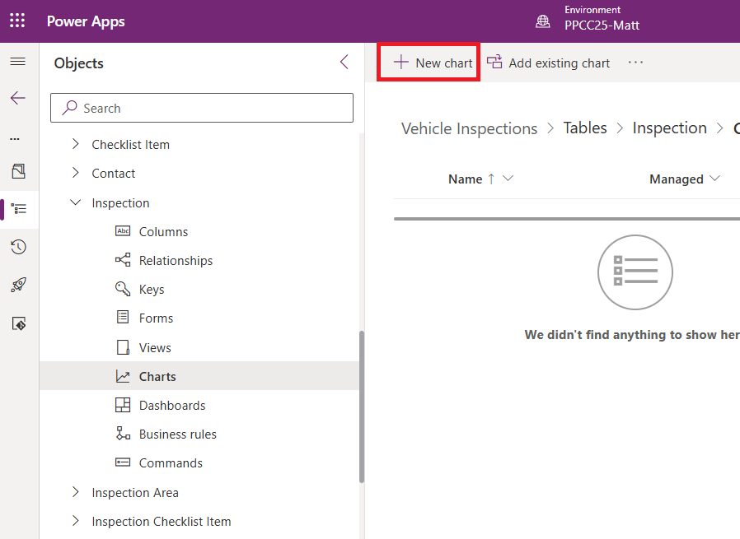

1. Select a bar chart. Name the chart Inspections By Type. Choose the legend series Created On and the aggregation type Count:All. Pick the horizontal axis labels Inspection Type. Save and close the chart.

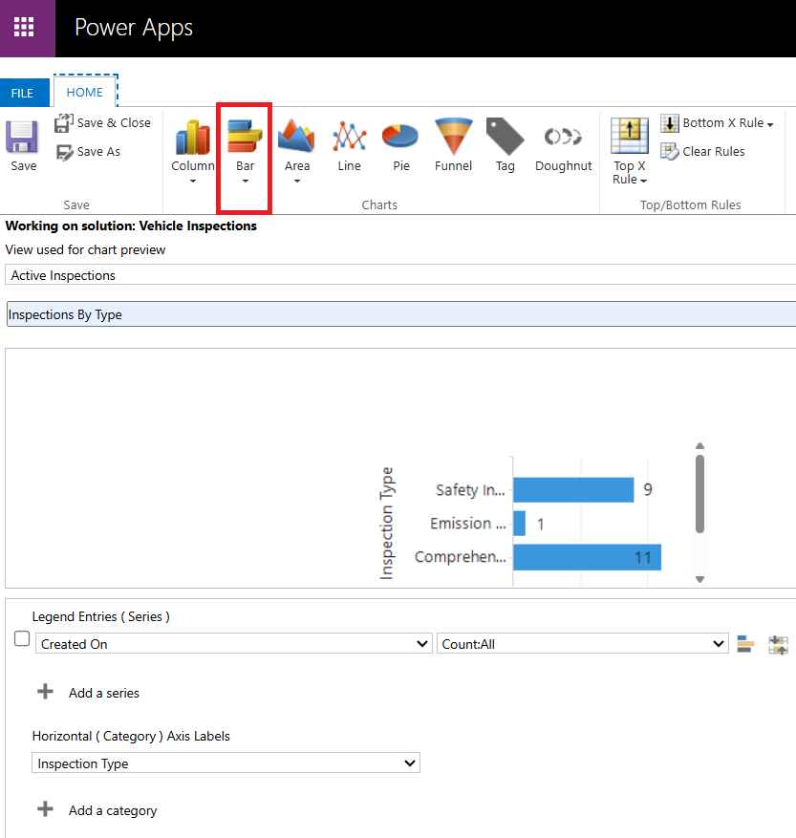aa

1. The new chart will appear inside of the solution.

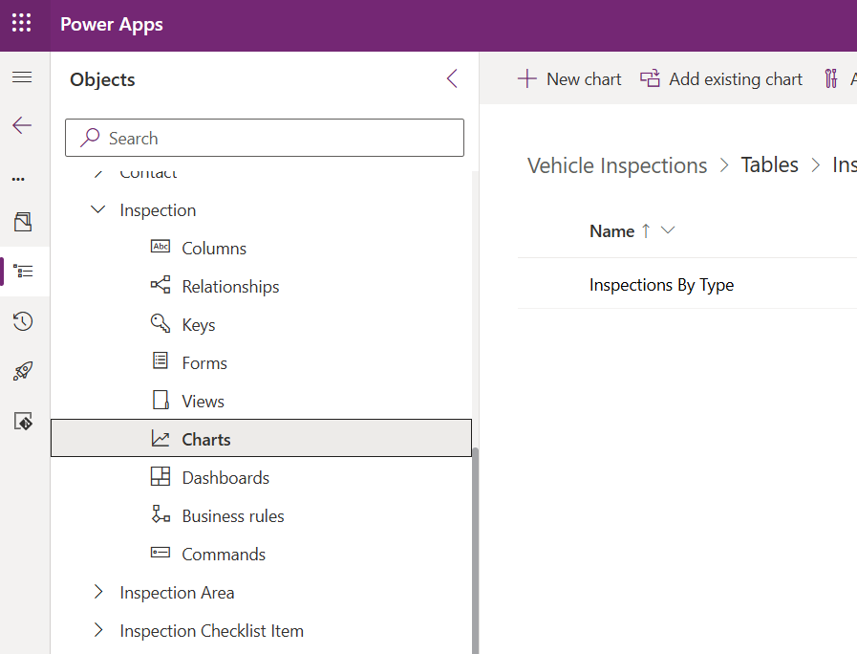

## Add A Dashboard To The Model Driven App

Dashboards are collections of charts and views. We will create a new dashboard and add it to the model-driven app

1. Select All objects in the solution then choose New > Dashboard > 2-Column overview

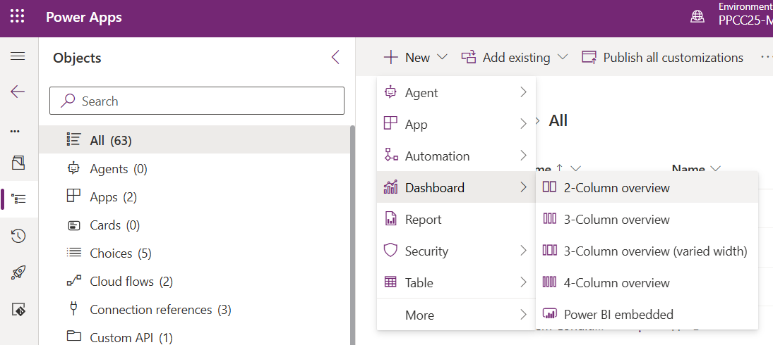

1. Name the dashboard “Inspection Dashboard.” Select the top-left section and press the Chart button.

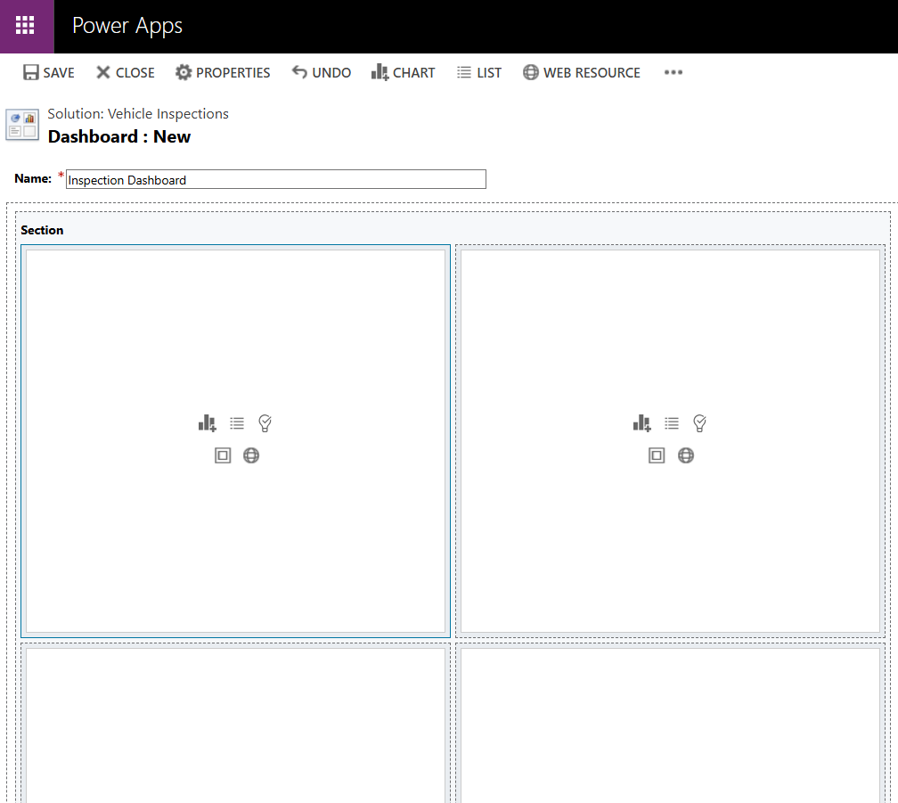

1. Select the following options then press the Add button:
   * Record Type: Inspection
   * View: Active Inspections
   * Chart: Inspections By Type

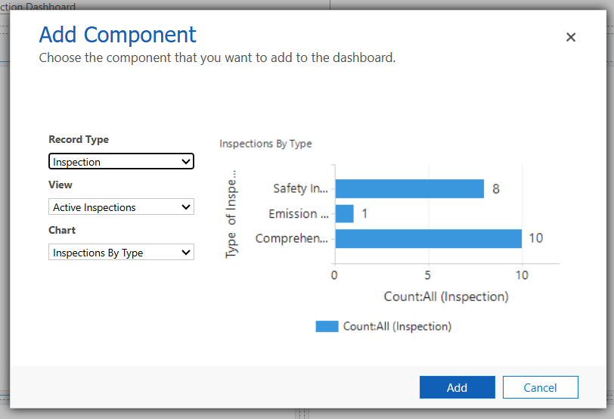

1. Select the top-right section then press the List button.

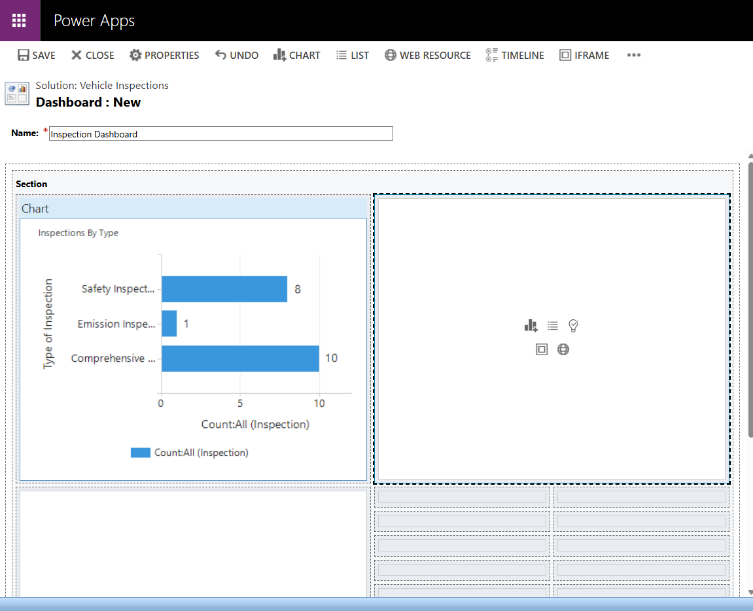

1. Choose the following options then press the Add button:
   * Record Type: Inspections
   * View: Active Inspections

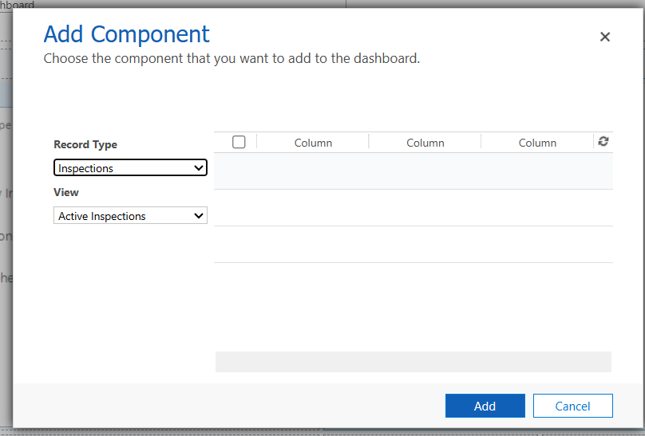

1. Save and close the dashboard.

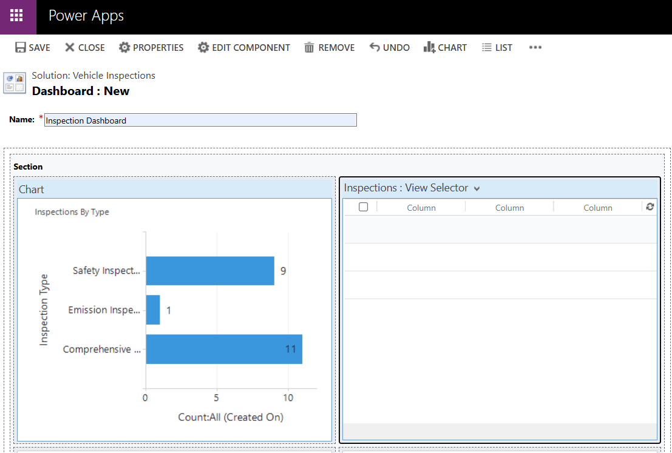

1. Go to the model-driven app and add a new Dashboard.

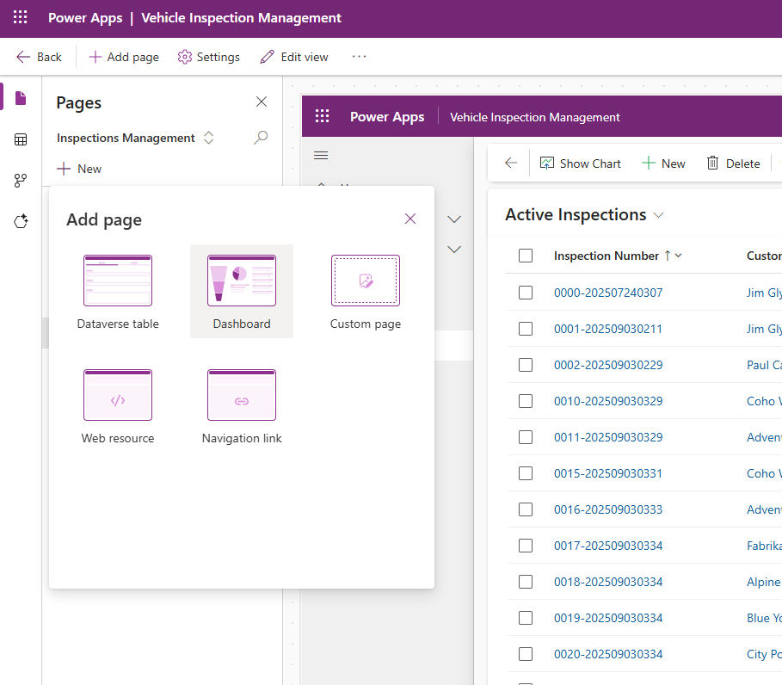

1. Choose the Inspection Dashboard.

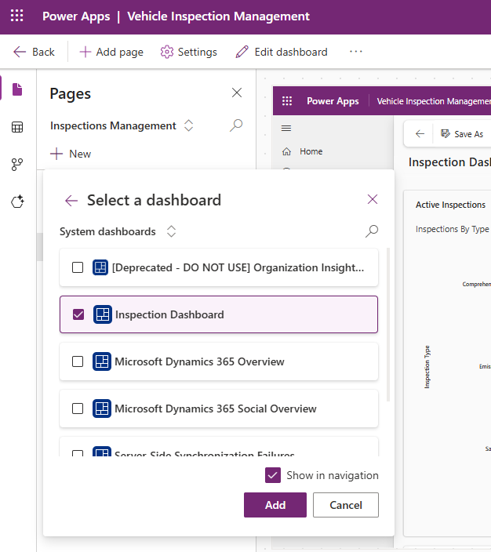

1. The dashboard appears in model-driven app.

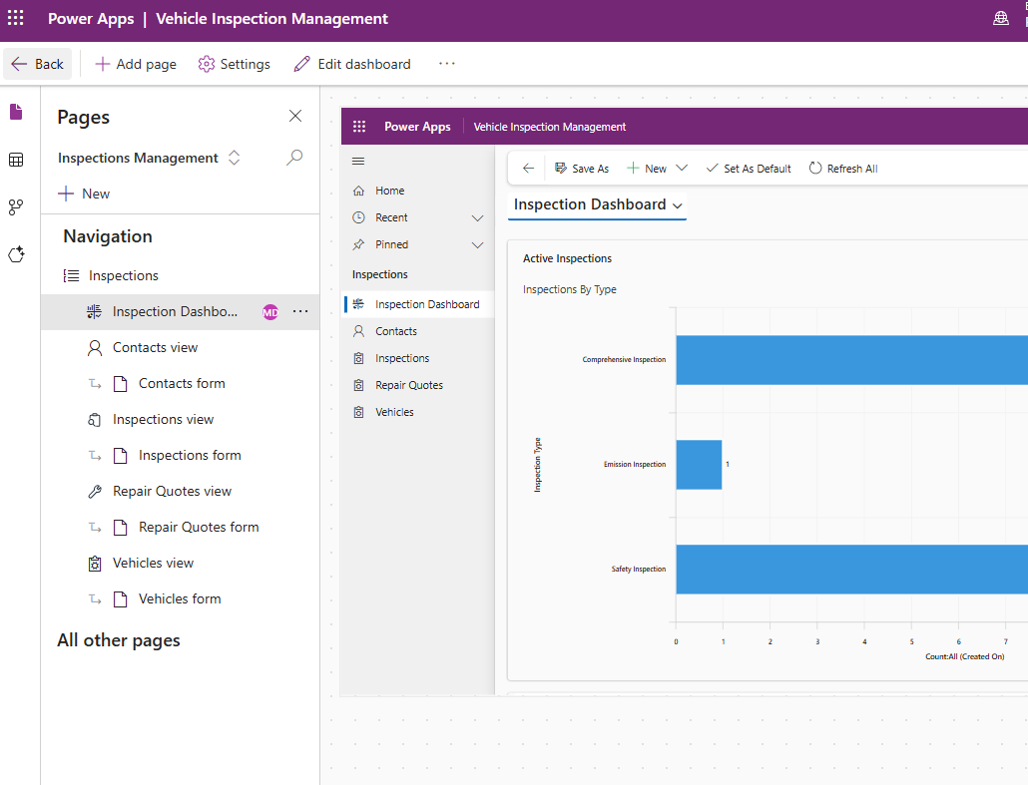

## Apply A Theme To A Model-Driven App (Optional)

We can change the model-driven app banner color by applying a theme file, but not much else. By design, model-driven apps look-and-feel is not very customizable.

1. In the Vehicle Inspections solution, open the Data web resource named PPCC2025AppTheme and click on the URL. The code which appears here is a settings file.

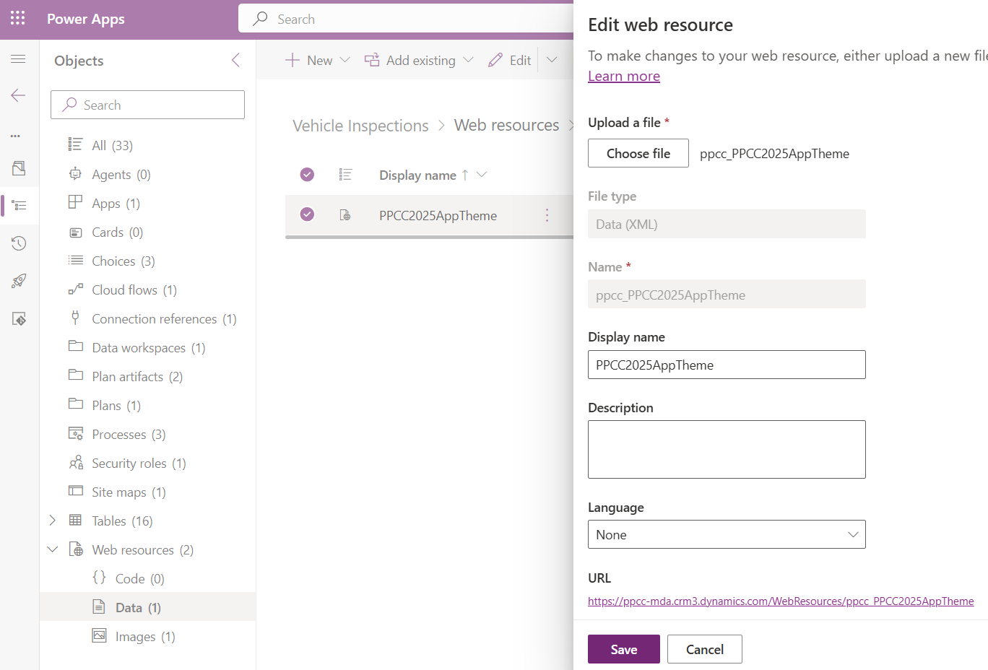

1. Add an existing Setting to the solution named Custom Theme Definition.

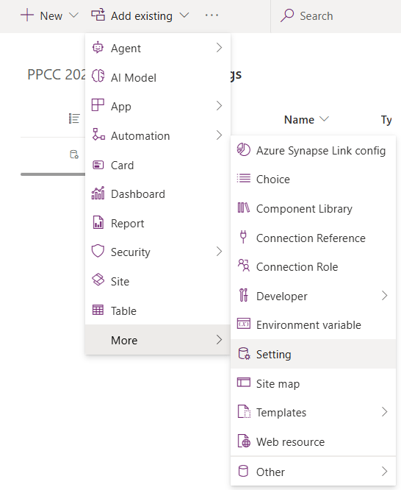

1. Add a setting app value for Vehicle Inspection Management “ppcc_PPCC2025AppTheme” then press Save.

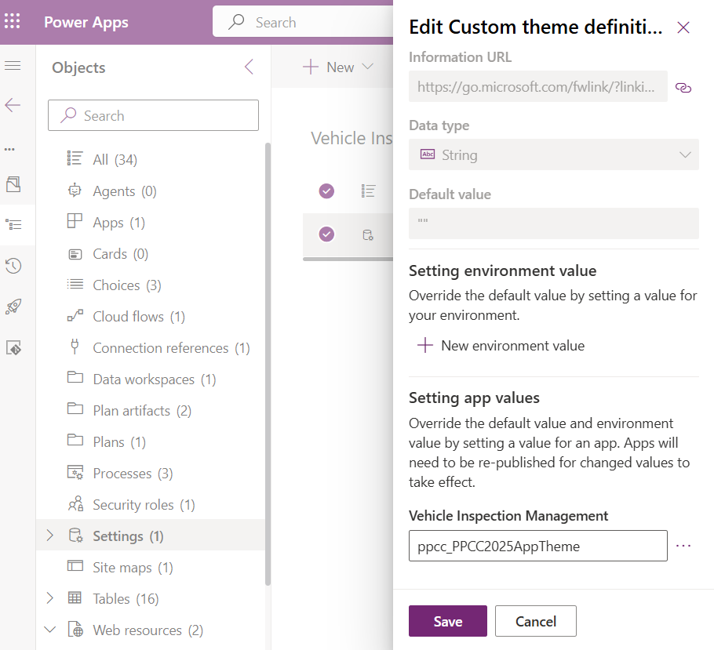

1. Press the Publish all customizations button.

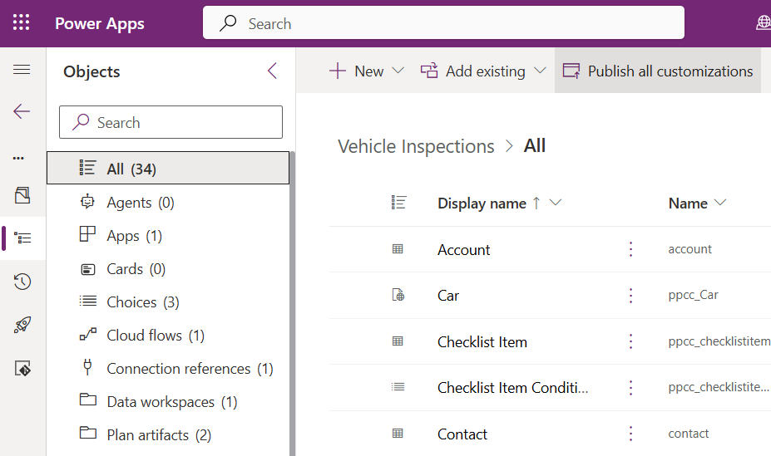

1. Once the settings changes are published it the app will have a header bar with a different color.

